AUTOMATIC CLASSIFICATION OF CRIME-RELATED
TEXT REPORTS USING NLP

YAASIIN MOHAMUUD ABDULLAAHI
NAIMA ABDIAZIZ SAID
NASTEHA MOHAMUUD MOHAMED
NAJMA MUHIDIIN MOHAMED

SUBMISSION OF GRADUATION PROJECT FOR
PARTIAL FULFILLMENT OF THE
DEGREE OF BACHELOR OF SCIENCE IN
COMPUTER APPLICATIONS

JAMHURIYA UNIVERSITY OF SCIENCE AND
TECHNOLOGY (JUST)
FACULTY OF COMPUTER & INFORMATION
TECHNOLOGY

AUGUST 2026

ORIGINAL LITERARY WORK DECLARATION
Name of Candidate 1: YAASIIN MOHAMUUD ABDULLAAHI ID: ____________
Name of Candidate 2: NAIMA ABDIAZIZ SAID ID: ____________
Name of Candidate 3: NASTEHA MOHAMUUD MOHAMED ID: ____________
Name of Candidate 4: NAJMA MUHIDIIN MOHAMED ID: ____________
Name of Degree: Bachelor of Science in Computer Applications
Title of Project/Thesis (“this Work”):
AUTOMATIC CLASSIFICATION OF CRIME-RELATED TEXT REPORTS USING NLP
Field of Study: Computer Applications
We the undersigned do solemnly and sincerely declare that:
(1) We are the authors/writers of this Work.
(2) This Work is original.
(3) Any use of any work in which copyright exists was done by way of fair dealing and for permitted purposes and any excerpt or extract from, or reference to or reproduction of any copyright work has been disclosed expressly and sufficiently and the title of the Work and its authorship have been acknowledged in this Work;
(4) We do not have any actual knowledge nor ought we reasonably to know that the making of this work constitutes an infringement of any copyright work.
(5) We hereby assign all and every right in the copyright to this Work to Jamhuriya University of Science and Technology (“JUST”), who henceforth shall be owner of the copyright in this Work and that any reproduction or use in any form or by any means whatsoever is prohibited without the written consent of JUST having been first had and obtained.
(6) We are fully aware that if in the course of making this Work we have infringed any copyright whether intentionally or otherwise, we may be subject to legal action or any other action as may be determined by JUST.

Candidate 1’s Signature: ____________ Candidate 2’s Signature: ____________
Candidate 3’s Signature: ____________ Candidate 4’s Signature: ____________
Date: ____ / ____ / ________
Subscribed and solemnly declared before,
Supervisor’s Name: _______________________ Date: ____ / ____ / ________
Supervisor’s Signature: ___________________ Designation: ________________

DEDICATION
We dedicate our dissertation work to our family and many friends. A special feeling of gratitude goes to our loving parents, whose words of encouragement and push for tenacity ring in our ears. We also dedicate this work to the Somali community and to all who strive for safer digital spaces through education, technology, and public service.

ABSTRACT
Social media platforms continuously publish large volumes of unstructured text. In a security context, posts must be analysed and separated into crime-related and non-crime-related content so that investigators can prioritise genuine threats. Manual sorting of such posts is slow and error-prone. This study develops BAREAI, an Artificial Intelligence based Natural Language Processing (NLP) system that automatically classifies social media posts and related text reports as crime-related or non-crime-related. A labelled dataset of 9,999 Somali-oriented samples was used, comprising 5,000 crime-related and 4,999 non-crime-related texts. After preprocessing and TF-IDF feature extraction, several supervised models were trained and compared, including Logistic Regression, Support Vector Machine (SVM), and Random Forest. Random Forest achieved the best performance with approximately 89.55% accuracy, precision, recall, and F1-score on the held-out test set and was selected for deployment. The model is served through a Flask API and integrated into a web application that provides Text Analysis, File Analysis, URL Analysis, and Batch Analysis, together with case management and monitoring tools. The findings demonstrate that NLP-based classification can reduce manual triage effort and support faster crime detection from social media streams in low-resource settings.
Keywords: Crime Classification, NLP, Machine Learning, Social Media, Crime Detection

ACKNOWLEDGEMENT
First and foremost, we thank Allah (SWT) for the guidance, strength, and opportunity to complete this Final Year Project successfully.
Secondly, we express our deepest gratitude to our parents for their continuous moral and financial support throughout our academic journey.
Thirdly, we thank our supervisor for valuable guidance, constructive feedback, and encouragement during the design, implementation, and writing of this thesis.
Fourthly, we acknowledge Jamhuriya University of Science and Technology (JUST) for providing the academic environment and resources required to undertake this research.
Finally, we thank our lecturers and classmates for knowledge shared, advice offered, and support given during the course of this project.

TABLE OF CONTENTS
ORIGINAL LITERARY WORK DECLARATION i
DEDICATION ii
ABSTRACT iii
ACKNOWLEDGEMENT iv
TABLE OF CONTENTS v
LIST OF FIGURES viii
LIST OF TABLES x
LIST OF ABBREVIATIONS xi
CHAPTER ONE: INTRODUCTION 1
1.1 Background of the Study 1
1.2 Problem Statement 5
1.3 Research Objectives 7
1.3.1 General Objective 7
1.3.2 Specific Objectives 7
1.4 Research Questions 8
1.5 Significance of the Study 8
1.6 Scope of the Study 9
1.7 Organization of the Study 10
CHAPTER TWO: LITERATURE REVIEW 12
2.1 Introduction 12
2.2 Impact of Crimes on Social Media 16
2.3 Traditional Classification Techniques in Crimes 20
2.4 Cybercrime Detection in Social Media 24
2.5 Challenges in the Classification of Crime-Related Text 28
2.6 Related Work 32
2.7 Proposed System 36
CHAPTER THREE: METHODOLOGY 38
3.1 Introduction 38
3.2 System Overview 39
3.3 System Features 41
3.4 System Architecture 45
3.5 Data Acquisition and Preprocessing 48
3.6 Feature Engineering / Representation 51
3.7 Model / Algorithm Development 53
3.8 Requirements 57
3.9 Feasibility Study 60
3.10 System Design 62
CHAPTER FOUR: IMPLEMENTATION AND RESULTS 66
4.1 Dataset Description 66
4.2 ML Pipeline Implementation 68
4.3 System Design and Deployment 72
4.4 Website Interface Screenshots 76
4.5 Data Visualization (Results Presentation) 86
4.6 Model Comparison 90
CHAPTER FIVE: DISCUSSION AND CONCLUSION 93
5.1 Introduction 93
5.2 Interpretation of Results 94
5.3 Contribution to Knowledge 96
5.4 Challenges and Limitations 98
5.5 Future Work 99
5.6 Final Conclusion 100
REFERENCES 102
APPENDIX A: FIGURE INDEX 108
APPENDIX B: TABLE INDEX 110

Automatic Table of Contents (update in Microsoft Word):
ORIGINAL LITERARY WORK DECLARATION i
DEDICATION ii
ABSTRACT iii
ACKNOWLEDGEMENT iv
TABLE OF CONTENTS v
LIST OF FIGURES x
LIST OF TABLES xi
LIST OF ABBREVIATIONS xii
CHAPTER ONE: INTRODUCTION 1
1.1 Background of the Study 1
1.2 Problem Statement 4
1.3 Research Objectives 5
1.3.1 General Objective 5
1.3.2 Specific Objectives 5
1.4 Research Questions 5
1.5 Significance of the Study 5
1.6 Scope of the Study 6
1.7 Organization of the Study 6
CHAPTER TWO: LITERATURE REVIEW 10
2.1 Introduction 10
2.2 Impact of Crimes on Social Media 14
2.3 Traditional Classification Techniques in Crimes 17
2.4 Cybercrime Detection in Social Media 21
2.5 Challenges in the Classification of Crime-Related Text 24
2.6 Related Work 27
2.7 Proposed System 30
CHAPTER THREE: METHODOLOGY 34
3.1 Introduction 34
3.2 System Overview 34
3.3 System Features 36
3.3.1 Authentication and Authorization 36
3.3.2 Automated Crime Text Classification 36
3.3.3 Multi-Source Input Analysis 36
3.3.4 Blacklist Monitoring 37
3.3.5 Case Management and Notifications 37
3.3.6 Dashboard, Reports, and Audit Logging 37
3.4 System Architecture 37
3.5 Data Acquisition and Preprocessing 39
3.5.1 Dataset Source 39
3.5.2 Data Preprocessing Steps 40
3.6 Feature Engineering / Representation 41
3.7 Model / Algorithm Development 42
3.7.1 Baseline Model and Model Selection 42
3.7.2 Model Evaluation 43
3.7.3 Model Deployment Framework 43
3.8 Requirements 44
3.8.1 System Requirements 44
Hardware Requirements 44
Software Requirements 44
3.8.2 User Requirements 45
3.8.2.1 Functional Requirements 45
3.8.2.2 Non-Functional Requirements 45
3.9 Feasibility Study 45
3.9.1 Technical Feasibility 45
3.9.2 Economic Feasibility 46
3.9.3 Operational Feasibility 46
3.9.4 Schedule Feasibility 46
3.10 System Design 46
3.10.1 Use Case Diagram 46
3.10.2 Database Design 48
CHAPTER FOUR: IMPLEMENTATION AND RESULTS 52
4.1 Dataset Description 52
4.2 ML Pipeline Implementation 53
4.3 System Design and Deployment 55
4.3.1 Backend Implementation 55
4.3.2 Frontend Implementation 55
4.3.3 AI Service Integration 55
4.3.4 Deployment Topology 56
4.3.5 Implemented User Interface Modules 57
4.4 Website Interface Screenshots — Feature Walkthrough 67
4.5 Data Visualization (Results Presentation) 68
4.6 Model Comparison 71
4.7 Detailed Testing Scenarios 73
CHAPTER FIVE: DISCUSSION AND CONCLUSION 75
5.1 Introduction 75
5.2 Interpretation of Results 75
5.3 Contribution to Knowledge 76
5.4 Challenges and Limitations 76
5.5 Future Work 76
5.6 Final Conclusion 77
APPENDIX A: FIGURE INDEX 80
APPENDIX B: TABLE INDEX 80
APPENDIX C: SAMPLE CLASSIFICATION EXAMPLES 82
APPENDIX D: RECOMMENDED VIVA DEMONSTRATION SCRIPT 84
APPENDIX E: EXTENDED DISCUSSION NOTES 85
REFERENCES 87

Tip: In Microsoft Word, select the automatic TOC above → right-click → Update Field → Update entire table.

LIST OF FIGURES
Figure 3.0: Multi-Source Input Analysis Features 39
Figure 3.1: BAREAI System Architecture Pipeline 45
Figure 3.2: Text Preprocessing Flowchart 49
Figure 3.3: NLP Crime Classification Pipeline 54
Figure 3.4: Use Case Diagram of BAREAI 63
Figure 3.5: Logical Database Schema of BAREAI 64
Figure 4.1: Dataset Class Distribution (N = 9,999) 66
Figure 4.2: End-to-End Classification and Case Dispatch Flow 69
Figure 4.3: ML Pipeline Implementation Stages 70
Figure 4.4: Local Deployment Topology of BAREAI Services 74
Figure 4.5: BAREAI Landing / Home Page 76
Figure 4.6: BAREAI Login Page 77
Figure 4.7: Text Analysis Page with Crime / Non-Crime Result 78
Figure 4.8: URL Analysis Page 79
Figure 4.9: File Analysis Page 80
Figure 4.10: Batch Analysis Page 81
Figure 4.11: Administrator Dashboard 82
Figure 4.12: Investigation Case Management Page 83
Figure 4.13: Blacklist and Monitoring Page 84
Figure 4.14: Notifications and Reports Page 85
Figure 4.15: Comparative Performance of Classification Models 87
Figure 4.16: Confusion Matrix of the Random Forest Classifier 88
Figure 4.17: Evaluation Metrics of the Selected Random Forest Model 89

LIST OF TABLES
Table 3.1: Dataset Column Description and Summary Statistics 33
Table 3.2: Feature Engineering and Split Configuration 34
Table 3.3: Model Evaluation Results on the Test Set 35
Table 3.4: Hardware Requirements 37
Table 3.5: Software Requirements 38
Table 3.6: Database Collections Summary 41
Table 4.1: Implemented Interface Modules 46
Table 4.2: Ranked Model Comparison Summary 49

LIST OF ABBREVIATIONS
AI Artificial Intelligence
API Application Programming Interface
FYP Final Year Project
JSON JavaScript Object Notation
JUST Jamhuriya University of Science and Technology
ML Machine Learning
NLP Natural Language Processing
REST Representational State Transfer
RF Random Forest
SVM Support Vector Machine
TF-IDF Term Frequency–Inverse Document Frequency
URL Uniform Resource Locator

CHAPTER ONE: INTRODUCTION
This chapter introduces the research problem and motivation for developing an automated NLP system that analyses social media posts and related digital text reports. Clearly, the proposed BAREAI system classifies each input as either crime-related or non-crime-related. The chapter presents the background, problem statement, objectives, research questions, significance, scope, and organisation of the study.
In practical terms, BAREAI supports investigators and authorised users through four primary analysis features: Text Analysis (paste post content), File Analysis (PDF, DOCX, or TXT upload), URL Analysis (extract and classify webpage text), and Batch Analysis (classify multiple posts in one request). These features are detailed further in Chapter Three and demonstrated in Chapter Four.

1.1 Background of the Study
A crime is an illegal act that is penalized by the state or another authority. The term “crime” refers to an offence that harms not only a single person but also a community, society, or state (Khan et al., 2022). Criminal activity is present daily, in a multiplicity of illegal actions in several domains, such as drug trafficking, computer crime, and theft, to just mention a few examples. Upon the occurrence of a crime, criminal police investigators are in charge an d start a set of actions to enable the construction of the so-called 'chain of custody' to identify the alleged culprits and to present them in court.(Carnaz et al., 2021). Classification of Crime Reports is an important process in the analysis and management of crime-related data.
In this Context: An ID, such as the type of crime, date and time of the incident, location, witnesses, and description of the incident(Hariguna & Ruangkanjanases, 2023). Text classification specifically focuses on categorising and organising text data to facilitate easier management and analysis. These techniques leverage natural language processing, machine learning, and data mining to extract meaningful patterns and categorize text data. thereby transforming unstructured text into structured, actionable insights (Taha et al., 2024). Crime-related data is exploding due to the constant reporting and distribution of crimerelated information on the internet in the rapidly evolving information technology and communication era. Online newspapers and social networks offer real -time
information about what is happening in a specific location, at a particular moment, and with numerous cause(Ali et al., 2023). Natural language processing is an area of computer science that is primarily concerned with transforming natural language into a formal language, such as a programming language, so that a computer can process and understand it, mainly combining algorithms. (Martínez Hernández et al., 2026). Automated Crime Report Analysis is a technological approach used to automate the process of evaluating, sorting and understanding crime reports that enter the police system or relevant government agencies(Hariguna & Ruangkanjanases, 2023). The rise in cybercrime and the complexity of multilingual and code -mixed complaints present significant challenges for law enforcement and cybersecurity agencies.
These organizations need automated, scalable methods to identify crime types, enabling efficient processing and prioritization of large complaint volumes. Manual triaging is inefficient, and traditional machine learning methods fail to capture the semantic and contextual nuances of textual cybercrime complaints(Rani et al., 2024). The proposed research paper explores the application of machine learning techniques in crime analysis problem, specifically focusing on the classification of crime-related textual data. Through a comparative analysis of various machine learning models, inc luding traditional approaches and deep learning architectures, the study evaluates the data (Mussiraliyeva & Baispay, 2024) The 2021 amendment to South Korea’s Criminal Procedure Law has significantly enhanced the role of the police as investigative authorities.
Consequently, there is a heightened demand for advanced investigative expertise among the police, driven by an
increase in the number of cases each investigator handles and the extended time required for report preparation. This situation underscores the necessity for an artificial intelligence-supported system to augment the efficiency of investigators. (Park et al., 2024). The ability to be anonymous on social media and the lack of adequate resources to fight cybercrime are catalysts for the rise in criminal activities, especially in South Africa. We proposed a system that will analyse and detect crime in social media posts or messages. The new system can detect attacks and drug -related crime messages, hate speech, and offensive messages.(Lombo Lombo et al., 2022). The integration of machine learning techniques in crime analysis offers unprecedented opportunities to harness the vast amount of online textual data for enhancing public safety and security.
By overcoming inherent challenges and leveraging the capabilities of ML algorithms, researchers and law enforcement agencies can gain invaluable insights into criminal behaviour and trends, ultimately contributing to more effective crime prevention and intervention strategies (Mussiraliyeva & Baispay, 2024). In today’s world, security is the most prominent aspect that has been given higher priority. Despite the rapid growth and usage of digital devices, the measurement of crimes in underdeveloped countries is still challenging(Umair et al., 2020) The majority of Somalia's current crime reporting and management systems are manual. Labor-intensive and prone to human error. By creating an automated NLP framework especially suited for the Somali language, this study seeks to address these issues.
It is anticipated that this transition from manual sorting to AI -driven analysis will grea tly speed up law enforcement responses and enhance data integrity in the Somali security industry.

1.2 Problem Statement
Crime reports sent using digital channels (such as social media, emails, or online forms) ought to be processed and categorised instantly in a perfect law enforcement setting. This enables prompt prioritisation and routing to the appropriate department (su ch as cybercrime, homicide, or theft), guaranteeing a prompt response that can save lives and stop additional criminal behaviour. The majority of crime report classifications are now done by hand. Every day, thousands of text -based reports must be evaluated by human dispatchers or officers in order to determine the type of crime. Today's massive amount of digital data makes this manu al approach labour -intensive, slow, and prone to major delays.
The use of manual classification results in a number of serious problems: Slow Reaction: When a report is waiting in a queue, human error – fatigue brought on by information overload – causes reports to be misclassified or high -priority threats to be missed. Resource inefficiency: Instead of actively investigating and ensuring community safety, skilled staff devote hours to administrative sorting. This study suggests using natural language processing (NLP) to create an automated classification system. The system will be trained to examine the linguistic patterns of crime reports, classify them automatically with high accuracy, and identify urgent instances for prompt attention by utilising machine learning methods. The goal of this shift from manual to AI -driven sorting is to significantly increase the speed of police and court responses.

1.3 Research Objectives

1.3.1 General Objective
The main objective of this research is to develop and put into use an intelligent automated framework that uses machine learning and natural language processing to transform the way Security agencies classify crime reports. This framework will replace manu al sorting with high-Speed semantic analysis that guarantees operational efficiency and data integrity.

1.3.2 Specific Objectives
• To reduce the reliance on manual methods of classifying crime reports.
• To collect and preprocess crime-related text data for analysis.
• To extract and analyse key features from crime-related text data for accurate classification.
• To develop an automated NLP system for classifying crime-related text reports.

1.4 Research Questions
1. How to reduce the reliance on manual methods of classifying crime reports?
2. How to collect and preprocess crime-related text data for analysis?
3. How to extract and analyse key features from crime-related text data for accurate Classification?
4. How to develop an automated NLP system for classifying crime-related text reports?

1.5 Significance of the Study
The goal of this project is to create an AI -powered natural language processing system that can automatically categorize text reports pertaining to crimes, making it noteworthy. Researchers and law enforcement organizations can save time and money on manual data
analysis by automating the classification process. Decision -making procedures may be improved; the system can help create intelligent crime monitoring tools, and it can increase the accuracy of identifying various sorts of crimes. Additionally, by showing how Natural Language Processing (NLP) may be used practically in crime analysis, this study advances the academic subject of NLP.

1.6 Scope of the Study
The design, development, and assessment of a system based on Natural Language Processing (NLP) that automatically ascertains whether a given text report is related to a crime or not is the main objective of this study.

1.7 Organization of the Study
I. Chapter II: Literature Review The Literature Review chapter is the summary of the study conducted by the researcher on the existing literature and studies that are associated with the topic of the study. This study reviews the existing research conducted to determine the effectiveness of crime detection and text classification using Natural Language Processing (NLP) techniques. Additionally, this chapter aims to identify the various machine learning algorithms and approaches that have been implemented on social media data to classify and identify crimes. II. Chapter III: Methodology The third chapter discusses the methodology used for the research in this study. It shows how the social media data is collected and preprocessed. That is, in the stage of data preprocessing, the texts in social media posts are cleaned, tokenized, and the useful features are extracted.
This chapter also provides more light about the machine learning algorithms that are employed in this study to classify the social media posts as crime and non-crime. Hence, the researcher fully explained data preparation and selection of the machine learning algorithm used.
III. Chapter IV System Analysis, Design And Implementation. This chapter will discuss the analysis, design, and implementation of the proposed system, which is an NLP system to classify social media posts. It will discuss the system architecture, data flow, text preprocessing, feature extraction, and classification of social media text. It will also show the flow of social media text from the input to the output of the system. It will also discuss the coding structure of the system and the deployment of the system. IV. Chapter V: Conclusion and Recommendations This chapter concludes and summarizes all the findings from the study. It also discussed the validity of the experimental results. The study discussed how the NLP model is used to classify crimes on social media and some poss ible ways of improving it. Recommendations were made on how to improve the performance of the system.
These include increasing the number of samples for training and re-training the model for accuracy. The system could also be integrated into ex isting policing platforms for effective crime control.
Social media has become one of the fastest channels through which crime-related narratives circulate in Somalia and the wider Horn of Africa. Posts describing violence, theft, explosions, or threats can reach thousands of readers within minutes. At the same time, many posts are ordinary news, entertainment, or civic discussion and are therefore non-crime-related. An automated system must separate these two classes reliably so that investigators do not waste time on irrelevant content while still capturing genuine risk signals.
The decision to focus on binary classification—crime-related versus non-crime-related—was deliberate. Multi-class crime typing is valuable, but binary triage is the first operational bottleneck in many agencies. Once a post is flagged as crime-related, human experts can refine category, location, and urgency. BAREAI therefore concentrates on high-quality binary decisions delivered through practical web features: Text Analysis, File Analysis, URL Analysis, and Batch Analysis.
From a research perspective, the study contributes both an empirical comparison of classical NLP classifiers on Somali-oriented text and a full-stack prototype that embeds the best model into investigator workflows. The remaining chapters develop the literature foundation, methodology, implementation evidence, and conclusions required by the Faculty of Computer and Information Technology FYP guideline.
The background of the study also recognises that digital reporting channels are unevenly moderated. Anonymous accounts, code-mixed language, and rapidly edited posts complicate manual review. NLP methods can normalise and score text at a speed humans cannot match, provided that labelled examples and careful evaluation are available. This thesis therefore treats data quality and evaluation metrics as first-class methodological concerns rather than afterthoughts.
Finally, the organisation of chapters follows a consistent academic pattern: introduction and problem framing; literature and related work; methodology and design; implementation and results; and discussion with conclusions and recommendations. Each chapter begins with an introduction that states its purpose and ends by preparing the reader for the next stage of the argument.
Furthermore, digital crime reporting in under-resourced settings often lacks standardised forms. Social media posts therefore become informal incident streams. Classifying those streams into crime-related and non-crime-related buckets is a pragmatic first step toward structured case intake.
The significance of automation also extends to training junior officers. When the system highlights likely crime-related posts with confidence scores, supervisors can use those examples as teaching material while still retaining final human judgement.
Scope boundaries were set carefully: the system does not replace courts or forensic units; it supports triage. This boundary keeps ethical expectations realistic and matches undergraduate project constraints.

CHAPTER TWO: LITERATURE REVIEW

2.1 Introduction
Crimes are the most common social issues nowadays, affecting the economic growth, quality of life, and economy of any country. Crimes affect the reputation of a country on an international scale and affect the economy of the country by placing a financial burden on the government in hiring additional police forces. For the eradication of crimes, the government needs to adopt an optimized strategy and sustainable e -governance information systems. Algorithms that predict the occurrence of crimes based on time and location can help the government to deploy law enforcement in highly dangerous areas.(Umair et al., 2020) Criminal activity is present daily, in a multiplicity of illegal actions in several domains, such as drug trafficking, computer crime, and theft, just to mention a few examples.
Upon the occurrence of a crime, criminal police investigators are in charge an d start a set of actions to enable the construction of the so-called chain of custody to identify the alleged culprits and to present them in court. These actions are multidisciplinary and, depending on the crime, they may involve distinct tasks, such as d igital and biological forensics analysis, interviews with witnesses, and interrogations with suspects and other individuals who may be potentially implicated. al. (Carnaz et al., 2021) The classification of crime reports is a crucial process in the analysis and management of crime-related data. In this context, a crime report is written or digital information that contains various details about the crime incident, such as the type of crime, date and time of the incident, location, witnesses, and description of the incident. The goal of cri me
report classification is to group these reports into appropriate groups based on their characteristics, which facilitates efficient analysis, monitoring, and action by the authorities. One of the main benefits of classifying crime reports is their ability to aid law enforcement and investigation. By classifying crime reports by crime type, authorities can more easily identify potential crime patterns.(Hariguna & Ruangkanjanases, 2023) Crime-related data is exploding due to the constant reporting and distribution of crime related information on the internet in the rapidly evolving information technology and communication era. Online newspapers and social networks offer real -time information about what is happening in a specific location, at a particular moment, and with numerous causes.
These facts depict real-world events, such as accidents, innovations, conferences, natural disasters, or crime events. These resources have provided a substantial amount of crime data, which is the domain of their study, presenting a need to extract precise and valuable information to promote and strengthen the fighting capacities against crime capabilities, thus improving public protection and reducing the likelihood of future crime prospects. Moreover, informatio n possession and effective deployment are essential in fighting crime and are in high demand from various end-users.(Ali et al., 2023) Criminal detection and prediction constitute an essential practice in crime analysis, seeking to provide effective techniques for supporting law enforcement.
Researchers develop diverse strategies and solutions utilizing machine learning (ML) and deep learning (DL) algorithms to foresee or detect criminal activities that have demonstrated considerable potential in addressing crime detection issues (Al -harbi & Alghieth, 2025) Natural language processing is an area of computer science that is primarily concer ned with transforming natural language into a formal language, such as a programming language, so that a computer can process and understand it, mainly combining techniques from AI, linguistics, statistics, and computing for the development of algorithms. It is a
fundamental part of NLP as it focuses on understanding the meaning of words, phrases, or sentences and how they are used in a specific context.(Martínez Hernández et al., 2026) Extracting events from news stories as the aim of several Natural Language Processing (NLP) applications (e.g., question answering, news recommendation, news summarization) is not a trivial task, due to the complexity of natural language and the fact that news reporting is characterized by journalistic style and norms.
Those aspects entail scattering an event description over several sentences within one document (or more documents), applying a mechanism of gradual specification of event -related information.(Bonisoli et al., 2023) Automated Crime Report Analysis is a technological approach used to automate the process of evaluating, sorting, and understanding crime reports that enter the police system or relevant government agencies. The main objective of this method is to improve efficiency and effectiveness in crime data management, as well as enabling authorities to respond to crime events faster and more accurately. Automated analysis of crime reports involves using technologies such as artificial intelligence and natural language processing to extract key information from incoming crime reports.
(Hariguna & Ruangkanjanases, 2023) The rise in cybercrime and the complexity of multilingual and code -mixed complaints present significant challenges for law enforcement and cybersecurity agencies. These organizations need automated, scalable methods to identify crime types, enabling efficient processing and prioritization of large complaint volumes. Manual triaging is inefficient, and traditional machine learning methods fail to capture the semantic and contextual nuances of textual cybercrime complaints.(Rani et al., 2024.)
The proposed research paper explores the application of machine learning techniques in the crime analysis problem, specifically focusing on the classification of crime -related textual data. Through a comparative analysis of various machine learning models, including traditional approaches and deep learning architectures, the study evaluates their effectiveness in accurately detecting and categorizing crime -related text data. The performance of the models is assessed using rigorous evaluation metrics, such as the area under the receiver operating characteristic curve (AUC -ROC), to provide insights into their discriminative power and reliability.(Mussiraliyeva & Baispay, 2024) The 2021 amendment to South Korea’s Criminal Procedure Law has significantly enhanced the role of the police as investigative authorities.
Consequently, there is a heightened demand for advanced investigative expertise among the police, driven by an increase in the number of cases each investigator handles and the extended time required for report preparation. This situation underscores the necessity for an artificialintelligence‐supported system to augment the efficiency of investigators. In response, their study designs a hybrid model that fine‐tunes two Transformer-based pretrained language models to extract 18 key pieces of information from legal documents automatically.(Park et al., 2024) The integration of machine learning techniques in crime analysis offers unprecedented opportunities to harness the vast amount of online textual data for enhancing public safety and security.
By overcoming inherent challenges and leveraging the capabilitie s of ML algorithms, researchers and law enforcement agencies can gain invaluable insights into criminal behaviors and trends, ultimately contributing to more effective crime prevention and intervention strategies(Mussiraliyeva & Baispay, 2024)
In the contemporary era, ensuring security has become a critical priority due to the rapid proliferation of digital technologies and devices. As digital adoption increases globally, especially in developing regions, monitoring and addressing crime accurate ly becomes increasingly complex and challenging. Research suggests that developing countries face persistent cybersecurity challenges and limitations in effectively detecting and combating digital crime and security risks in these environments (Yadav et al., 2020) In today’s world, security is the most prominent aspect that has been given higher priority. Despite the rapid growth and usage of digital devices, the measurement of crimes in underdeveloped countries is still challenging(Umair et al., 2020)
The discussion above reinforces that social media text must be analysed automatically and separated into crime-related and non-crime-related classes. This insight directly informs the design choices presented in the methodology chapter, including Text, File, URL, and Batch analysis features.

2.2 Impact of Crimes on Social Media
Social media representations of crime have the power to influence how the general public views crime, law enforcement, and the legal system. Inaccurate coverage of crime-related news can lead to mistakes, portrayal of crime as a necessity and a demand of t he time, which makes people sympathetic to the criminal and, in a way, encourages crime. It also undermines public confidence in the government and gives power to those who have taken the law into their own hands. Hate crime is the overrepresentation of cr imes committed by a certain segment of society against that segment, which has become a social media trademark and fosters hatred and negative perceptions toward that segment. (Abhishek Kumar, 2025) The Social media exposure of crime refers to the way crime -related content is shared, discussed, and highlighted on social media platforms.
Social media is now a major tool for people to know what is happening around them. It is now a necessary part of everyone's life, even for students. As the use of social media as a platform for gathering information continues, individuals will encounter posts that are related to crime incidents.
People will have their own insights based on the topic, which might affect them in some ways. Social media networks make it simple to spread both positive and negative emotions among individuals. Criminology students often recognize that social media can serve as an educational tool. By exposing users to real -time information about crime trends and safety issues, social media can enhance public awareness. Research indicates that platforms like Twitter and Facebook facilitate the rapid dissemination of crimerelated information, potentially empowering communities to take preventative measures. Exposure to crime on social media can distort public perception, leading to fear and anxiety.(Ezekwe, 2025) According to the data, a large number of students share excessive amounts of information via social media and emails, which could endanger them.
The majority of organizations have put in place multiple security measures to prevent information from leaking on social media. Cyberbullying has become widespread, particularly among those who are vulnerable to it. Social media is frequently the target of security threats such as hacking, spoofing, spamming, cyberstalking, Trojan horses, worms, viruses, and exposure scams; for this reason, government and ICT policies have addressed these problems. Higher education institutions must devote more funds to student education, awareness, research and development, IT security, and social media crimes.(Benard et al., 2021).
Social media is substantially affecting the world’s dynamics and proves to be particularly true when it comes to the legal realm.3 As a matter of fact, in this digital era, these massive online platforms give rise to new challenges and opportunities in rel ation to the existing framework of international criminal law (hereinafter ‘ICL’).(Ali, 2021)
The penetration of social media into nearly every aspect of contemporary life has reshaped patterns of communication, information consumption, and interpersonal interaction. Beyond its role as a tool for social connectivity, digital platforms have emerged as influential spaces where narratives of crime circulate rapidly and where offenders increasingly exploit online affordances to facilitate unlawful behavior. Their study investigates the extent to which these platforms affect both criminal conduct and pub lic interpretations of crime trends within modern societies.
The purpose of the research is to analyze how social media environments enable planning, performance, and dissemination of criminal acts, while also shaping public emotions, risk perceptions, and trust in institutions responsible for maintaining public order.(Rashid et al., 2025) These days, people utilize a variety of social media platforms to share information with friends, family, and other people for official, business, and personal reasons. Cyberstalking is another major problem brought on by social media use. Cyberstalking has been recognized as an increasingly prevalent anti -social issue that impacts victims, educational institutions, and human society as a whole.
Cyberstalking on social media must be detected by an intelligent system.(Gautam & Bansal, 2022) Numerous risks that have been recognized and categorized are present on social media, according to the International Journal of Network Security & Its Applications. Al Hasib categorized social networking threats into three categories: identity-related threats, which include phishing, friending malicious actors, profile squatting, stalking, and corporate espionage; privacy-related threats, which include the sharing of private information on social media; and information security threats, which include well-known security threats on social media like worms, viruses, and cross -site scripting. Similar to this, Fire et al. divided the threats associated with social media (Umeugo, 2023).
In today’s digital age, the widespread growth of the digital media sector and information technology has significantly improved communication flexibility through platforms such as Facebook, Twitter, Instagram, and others. These platforms, driven by Web 2.0 technologies, enable global connectivity, fostering social interaction and community building beyond geographical constraints. Despite their advantages, such as accessibility and interactivity, social media also pose risks like cybercrimes and threats to security, making it crucial to evaluate their impact on societal security in the United Arab Emirates (UAE). The research problem focuses on how social media simultaneously affects societal security, aiming to identify strategies to mitigate risks while pr eserving its benefits.(Alnaqbi & Ali, 2025)
The discussion above reinforces that social media text must be analysed automatically and separated into crime-related and non-crime-related classes. This insight directly informs the design choices presented in the methodology chapter, including Text, File, URL, and Batch analysis features.

2.3 Traditional Classification Techniques in Crimes
Traditional methods of crime prevention and detection have played an essential role in maintaining law and order within communities. These methods are characterized by their reliance on human intervention, community participation, and well -established policing practices. This section discusses these key traditional methods, highlighting their strengths and limitations. (Apene et al., 2024) The efficacy of several machine learning models, such as LSTM, GRU, Random Forest, SVM, and Logistic Regression is examined in th eir study. Based on thorough testing, the Random Forest, SVM, and Logistic Regression models performed well on tasks involving the classification of crimes. Traditional inspection of a large number of crime reports, however, may be laborious and prone to human error.
However, the conventional manual classification of crimes based on textual descriptions is laborious, prone to human error, and frequently inconsistent. (Eldho,2023)
Moreover, the manual annotation of some visual content can be problematic from an occupational health and safety perspective, as the potential exists for individuals to be exposed to a large number of indecent and disturbing images. To further compound matters, forensic practitioners generally have limited background knowledge of big data, Artificial Intelligence, and data sciences to help create models tailored for their own practices. In order to make full use of large forensic image databases and remove associated practical issues, specialized high -performance and accurate computer vision (e.g., automatic recognition and content filtering) and data analytics tools are required.(Taha, 2024) Clustering is also another common technique used to predict patterns of geographic criminal history and behavior.
Remond and Baveja proposed a case -based reasoning (CBR) system that filtered out police cases for better prediction. It worked on noisy data and explained how police reports show only individual criminal activities and do not address gang crimes. Social networks are also used as a potential source of criminal activity indicators. Sadhana and Sangareddy used Twitter information to find real -time criminal offences. They also used the same data set to find the concentration of crime occurrences, and find large scale of hotspots. Thus, several techniques are used for analyzing crimes.(Hossain et al., 2020) From high -level categories to lower -level subtypes, the conventional classification of crime types is based on a hierarchical framework.
This tree -based classification lacks tricategory semantic linkages since it recognizes different types of crimes as mut ually independent when they do not branch from the same higher-level category. In any event, the prevailing trend is on the initial classification of crime types offered by each nation or local organization, which consists of hierarchical structures from a single point of view, ranging from high -level categories to lower-level subtypes. When crime types are not
mutually independent, this conventional tree -based classification recognizes them as such. branch from the same higher -level category ; hence, there are no semantic connections across categories. Even though they may be closely linked, crime types that originate from distinct high -level categories are handled very differently. For example, the crime type "disturbing the peace" and the crime type "liquor—drinking in public" may be perceived as inherently related since, from a police standpoint, the two offens es are related.
However, according to the city of Boston's crime classification, "disturbing the peace" falls under the category of "disorderly conduct," while "drinking in public" falls under the category of "liquor violation."(Crivellari & Ristea, 2021) Police in the United Kingdom use a hierarchical framework of UK Home Office codes, classes, sub -classes, and offence categories to categorize crime events. These classifications correspond to the Notifiable Offence List, which, for each class, corresponds to a pertinent law that is used to prosecute people who are thought to have committed a specific crime. For example, code 28/3, class "Burglary," subclass "Residential Burglary," offence category "28F Attempted Burglary— Residential," and its application related to Section 9 of the Theft Act (1968) are used to record an attempted residential burglary.
The aforementioned categories were created to facilitate a variety of criminal justice procedures and allow for comparisons in crime statistics both within and between jurisdictions. However, even if this method of categorization is essential for the criminal justice system's administrative requirements, crimes may not adequately describe the ecological aspects of real-world criminal issues. Simply put, not all offenses of a given classification are created equal. Although classifying them as such makes administrative sense, it might not be the best way to comprehend the kinds of criminal opportunities and behaviors that arise in a given context to cause crime problems. (Birks et al., 2020)
Using text mining, natural language processing, and machine learning approaches, our system tackles the problem of classifying unstructured legal documents by organizing and analyzing this data and extracting reports related to crime scenes. Our work stand s out because we created a crime lexicon with 151 related terms and 70 crime instruments that were taken from different forensic sources. Despite being regarded as rather modest, it helped provide positive categorization results. To enhance crime scene investigation, the suggested crime dictionary can be expanded, used in sophisticated searches, and linked with police databases. (Bifari et al., 2024) For a limited portion of the crime data sets, K-Nearest Neighbor (KNN), Support Vector Machines (SVM), decision trees, random forests, Naive Bayes, and so forth are comparatively more effective.
The fundamental framework of crime prediction is shown in Fig. 1. A plan based on conventional machine learning is presented in Part (a). First, a training set and a test set are created from the data set. In order to achieve an appropriate representation of the crime data, the algorithm's fundamental requirement is to extract the crucial information that can represent the crime event data. Since there are many various kinds of crime data, it is vital to choose pertinent attribute data and then extract all of the data's features at once to increase the data's capacit y for effective expression. The crime is then forecasted using a range of machine learning algorithms, including support vector machines, decision trees, and linear regression models.( Yin, 2022)
The discussion above reinforces that social media text must be analysed automatically and separated into crime-related and non-crime-related classes. This insight directly informs the design choices presented in the methodology chapter, including Text, File, URL, and Batch analysis features.

2.4 Cybercrime Detection in Social Media
Cybercrime, to put it simply, is any criminal offense that uses a computer, digital devices, or the internet as a conduit. It falls under the category of contemporary crimes brought about by developments in the Internet and related technology. They might be categorized as hybrid offenses because, in contrast to more conventional crimes like robbery and theft,
which can be clearly localized in terms of time and place of occurrence, these crimes may have a connection that is challenging to pinpoint. Given the aforementioned, some authors have characterized it as a composite crime that includes cyber -dependent crimes made possible by the Internet and digital technology, as well as cyber-enabled crimes, including organized crime, fraud, forgery, theft, and money laundering. (Chinedu et al., 2021) Social media is being used for a variety of activities, but it can also lead to cybercrime. Online sharing of personal information can lead to crime. Victims may be reluctant to report crimes due to triviality, embarrassment, or lack of awareness. Social m edia monitoring can be used to augment conventional crime reporting. Social media is being used to facilitate criminal activity, much like other emerging technologies and communication channels.
It is imperative to protect private data being transferred vi a networks. (Abdalrdha et al., 2023) As with all cybersecurity and cybercrime issues, awareness is critical to help combat cybercrime on social media. Employees and organizations risk falling victim to cybercrime on social media. Awareness is also required to avert inadvertent perpetration and participation in cybercrime on social media. Organizations must incorporate cybercrime on social media awareness into general cybersecurity and cybercrime awareness training. Organizations must also measure their employees' cybercrime on social media awa reness levels to gauge the effectiveness of their awareness training programs.
Few studies exist on cybercrime awareness on social media, and most cybercrime awareness measurements do not consider cybercrime on social media.(Umeugo, 2023) According to the National White Collar Crime Center's "Criminal Use of Social Media" white paper, social media's recent rise has significantly altered the communication
environment. Social media sites like Instagram, Facebook, LinkedIn, YouTube, and Twitter are used daily by millions of individuals. People interact with each other via various sites. These channels are used for advertising, hiring new employees, and routine communication within the public sector. (Kaur et al., 2024) Online social networks (OSNs) such as Twitter are being used more and more in today's society to spread information globally. Online social networks have gained popularity because of their broad reach, streamlined dialogues, anonymity, and capacity to deli ver brief bursts of information. additionally could go into a channel for different forms of online harassment and bullying.
Common conversations and banter on social networking sites can occasionally turn explosive, leading to the unchecked expression of hate, harassment, and aggressiveness without the possibility of personal danger or reciprocal physical harm. Reports of mental and psychological health problems in recent years have been directly connected to cyberbullying, abuse, and harassment. Quickly identifying posts meant for abuse and expunging them from the network to lessen user exposure is necessary to stop these abusive activities.(Osho et al., 2020) The proliferation of digital communication platforms has led to the emergence of cyberbullying as a major social issue. In contrast to conventional bullying, cyberbullying enables offenders to reach victims at any time and from any place, transcending physical boundaries.
Particularly common among teenagers and young adults, this type of harassment has been connected to a number of detrimental effects, such as anxiety, sadness, and even suicidal ideation.(Altayeva et al., 2024) The findings show that many students share too much information through emails and social media, which may pose a threat to them. Most organizations have implemented multilayered security mechanisms information security may leak on social sites.
Cyberbullying has spread widely, especially among those who are prone to the practice of cyberbullying. Security attacks such as hacking, spoofing, spamming, cyber stalking, Trojans, worms, viruses, and exposure scams are common through social media, henc e the ICT policy and government policy have addressed such issues. Higher learning institutions need to invest more resources in training students, awareness, research and development, IT security, and social media crimes. (Benard et al., 2021) Threats from cybercrime are becoming more frequent every day.
Due to a lack of record keeping at relevant offices for a variety of reasons, including victims' presumptions about police response, users' ignorance of IT (information technology) acts on cybercrimes, and victims' incapacity to identify that they have been victimized, there is currently no foolproof, systematic, and trustworthy tool for reviewing cybercrimes. Reducing and categorizing cybercrimes may also be aided by promoting and educating the public about them, as well as by identifying and maintaining area-specific cybercrime rates. (Ch et al., 2020)
The discussion above reinforces that social media text must be analysed automatically and separated into crime-related and non-crime-related classes. This insight directly informs the design choices presented in the methodology chapter, including Text, File, URL, and Batch analysis features.

2.5 Challenges in the Classification of Crime-Related Text
Developing highly effective classifiers for such imbalanced datasets remains a significant challenge. As the dataset imbalance increases, the model tends to overfit the majority class, impairing its ability to achieve the desired performance on minority cl asses and leading to biased outcomes. Hence, the reliability of the model in real-world applications deteriorates, resulting in failures in critical scenarios where the accurate detection of minority classes is essential. (Taskiran et al., 2025) Multi-label text classification involves assigning more than one class to a text based on analyzing the terms in the text body. presents an open-world multi-label text classification. In this type of task, the possible classes are not available a priori. T he method needs to
perform topic modeling for subsequent text classification. So, it fragments the texts and sends them to an LLM for keyword extraction. The words are grouped, and the centroids of each group form the labels for text classification. The labels for the text c lassification procedure can all be available a priori. However, some researchers investigate the need for a dynamic update of the possible labels available for classification.(Vieira et al., 2025) Text classification can be done manually, but it is time -consuming and has a high cost. Manual classification comes with lots of errors and is less accurate because of human error and a lack of domain knowledge.
There was a huge revolution in text classification when machine learning models, such as the Support Vector Machines (SVM), Naive Bayes (NB), and Random Forest (RF) started to replace manual work, because these models not only reduce the time and cost but also are highly accurate for classification. Since the inception of machine learning models, numerous studies have been conducted to enhance, optimize, and refine the text classification process.(Palanivinayagam et al., 2023) The entire legal text is then divided into several predefined logical segments using structural characteristics. Next, the corresponding entities are extracted from each logical segment using a hybrid method of rules and deep learning. For simple entities, the rules and patterns are generated in the process of knowledge modeling to extract entities.
For complex entities, the pre -trained model Bidirectional Encoder Representations from Transformers (BERT) is introduced into the task of legal text information extraction, and is combined with Bi-directional Long Short-Term Memory (Bi-LSTM) and Conditional Random Field (CRF) algorithms to extract entities. It is effective in solving the problem of polysemy in legal texts.(Ren et al., 2022)
Beyond the analyses of free -text recorded by police, several studies have also explored how LDA topic models might be used to analyze crime -related phenomena discussed in unstructured content posted online. Combine LDA and collaborative representation classifiers in an attempt to detect ‘criminal intention’ in free -text extracted from online blogs. Relatedly, applies LDA topic models to geotagged tweets posted to the online platform Twitter in Chicago to generate neighborhood dominant topics indicative of t he ecology of a particular location.
These classifications are then used to positively augment a kernel density estimation -based crime prediction algorithm that seeks to estimate the levels of distinct offences in the immediate future.(Birks et al., 2020) A large language model (LLM) is a class of artificial intelligence models, typically based on deep learning, specifically designed to comprehend and generate human language. These models are characterized by their enormous size, often containing hundreds o f millions or even billions of parameters, which allows them to perform a wide range of natural language understanding and text generation tasks. For crime prediction tasks, an ML model can be trained on inputs to output labels from a fixed set of classes. However, recent advances in LLMs such as BERT and GPT -3 have introduced a novel approach known as prompting.
In prompting, there is typically no need for further training; instead, the model's input contains a task-specific text called a prompt.(Sarzaeim et al., n.d.) Securing large language models (LLMs) and NLP technology in general has not been a priority until recently. Yet mass adoption of this technology has led to deployment in contexts where security failures present a risk to individuals, organizations, and soc iety at large—demonstrated by, inter alia, LLM -assisted identity fraud phishing campaigns and automated influence operations If the latest NLP technologies are to withstand an increasing barrage of threats, NLP practitioners must now educate themselves on cybersecurity and cybersecurity practitioners must educate themselves on NLP. (Lent et
al., 2025) As another example, if there is a spike in traffic accidents during a festival period, local police could investigate the causes and allocate appropriate healthcare resources to the affected area. If drunken driving is a significant cause, poli ce could dispatch corresponding real -world statistics provided by administrative authorities. It conducted a case study on the efficacy of the news classification models using two reputable online news sources and seven prevalent types of crimes/accidents in Thailand.(Tuarob et al., 2025) Additionally, the issue of creating software tools and methods to aid in the investigation and prevention of criminal acts based on textual material disseminated online is still unsolved today.
Numerous applications are available to handle the problem, such as hate voice recognition, crime prediction, criminal pattern modeling, identification of crime related topics, etc. However, more effective techniques for analyzing criminal content in computer-mediated communication (CMC) are still required in order to prevent and solve crimes. Crime-related event extraction (CREE) is one of the most difficult and effective methods for identifying and forecasting criminal activity. The possibilities to gather organized data on a crime that has occurred or is likely to o ccur, compile this data, and then model a crime pattern are responsible for the success of the CREE job.
In the meantime, it is still very difficult to extract different kinds of crime-related events (CRE) from texts that are not police or witness narrative reports, even with the presence of studies pertaining to the CREE task. Additionally, materials produced in low-resource and underannotated languages make the Event Extraction process more challenging. (Khairova et al., 2023)
The discussion above reinforces that social media text must be analysed automatically and separated into crime-related and non-crime-related classes. This insight directly informs the design choices presented in the methodology chapter, including Text, File, URL, and Batch analysis features.

2.6 Related Work
In recent years, there has been a lot of interest in using artificial intelligence (AI) and machine learning (ML) to analyze crime (Hariguna & Ruangkanjanases, 2023). created a model for an adaptive decision -support system that is specifically for automatically analyzing and sorting crime reports in the context of e -government. Their study built an automated framework that used Natural Language Processing (NLP) techniqu es to pull out important information from reports that came in. The system was found to g reatly improve the efficiency of managing crime data, allowing authorities to respond to crime events more quickly and accurately. Looking at things together (Mussiraliyeva & Baispay, 2024).tested different machine learning methods - old styles and newer deep learning setups - to sort through text about crimes.
Rather than making assumptions, they turned to reliable methods - such as the Area Under the Receiver Operating Characteristic Curve (AUC-ROC) - to assess which model performed best. This shift led t o tangible insights for police departments, revealing patterns in offender behavior along with hints about future actions. These findings didn’t just show new tools - they helped shape smarter ways to stop crimes before they grow. Looking closely at tough investigation issues. (Park et al., 2024). created a mixed system to help South Korean law enforcement deal with new pressures after changes to the criminal procedure law in 2021 made cases harder to solve.
Instead of relying on manual review, their approach used two existing transformer-based models that had already been trained on legal data - tweaked slightly through additional learning - to pull out 18 crucial details from paperwork automatically. Looking back, it became clear how vital AI tools are when investigators face growing workloads and longer report prep intervals.When it comes to sorting public crime data, (Ali et al., 2023). suggested using a BERT-driven system to boost how news documents about crimes are sorted. Because clear information and swift deployment matter in crime prevention, their work highlighted the need for precise data pulling by different user groups. It turned out that using existing language models led to much stronger narrative handling - especially
for stories tied to criminal activity - than older approaches did. Focusing first on materials not in English, (Carnaz et al., 2021). faced little data by building a labeled set of crime linked Portuguese texts. Their effort showed how complex crime exams truly are blending fields like digital enforcement, interview handling, and keeping evidence trails intact. This dataset came together to build a base resource - key for creating NLP and machine learning tools that handle intricate crime cases across languages beyond English. Looking into better training data, Liu et al. (2023) explored ways to boost text variety while keeping results accurate. Instead of just adding more samples, they tried swapping words with synonyms, tossing in random terms, or reshuffling full sentences. These shifts helped spread out the examples used to teach models.
Because of this mix, the system learned to recognize patterns across deeper layers of meaning in crime classification. Over time, their findings pointed to stronger performance when faced with complex structures within criminal taxonomy. Starting with the challenge of uneven data spread, Franklin et al. (2024) introduced a new approach - "text-guided mix-up" - aimed at handling the longtail issue during sorting jobs. Drawing on how classes are linked in meaning, thanks to insights from pre -trained vision-language tools such as CLI P, they tapped into written guidance to ease imbalances shaped by sparse example sets. Looking at things this way fits well when studying crime patterns - some reported incidents happen much less often but still matter just as much in understanding what's happening. Looking at how African languages work, Sani et al.
(2025), along with Alabi's group two years earlier, studied what happens when language models adjust through a method called LAFT - using a model named AfriBERTa, among others. Looking into Sani and team’s work, they explored how people feel in Hausa using text analysis. Their findings show that tweaking big language models trained on multiple languages works better when taught only on African dialects. Since building a Somali crime news tool matters, it proves machines like AfriBERTa - built to adapt - can handle smaller languages well instead of just copying from English-based systems. Though rare, such shifts matter most where data runs thin.
Author & Year Description Methods Limitations
Carnaz et al. (2021) Focused on nonEnglish (Portuguese) crimelinked text classification. Construction of a labeled dataset for forensic tasks. Scarcity of labeled data in languages other than English. Liu et al. (2023) Explored data diversity in hierarchical multilabel classification.
Methods: Synonym replacement, random insertion/deletion/swap. Excessive data enhancement may lead to model over-fitting. Franklin et al. (2024)
Addressed longtailed label distribution in training.
Text-guided mix-up technique using semantic relations.
Traditional deep learning requires costly, large, balanced datasets. Sani et al. (2025)
Investigated sentiment analysis
Language-Adaptive
Fine-Tuning (LAFT) using AfriBERTa. Smaller languages often just copy English-based
The discussion above reinforces that social media text must be analysed automatically and separated into crime-related and non-crime-related classes. This insight directly informs the design choices presented in the methodology chapter, including Text, File, URL, and Batch analysis features.

2.7 Proposed System
The proposed system is an NLP (Natural Language Processing) based text classification system that classifies any given social media post as crime-related or non-crime-related. The dataset used for this proposed system consists of social media posts, which are manually labelled by humans as crime -related or non-crime-related. The output is generated after the preprocessing of the input text and then passing it to the machine learning and deep learning algorithms. The algorithms used in this proposed system are Support Vector Machine (SVM), Random Forest, and BERT. The preprocessed features of the input text are used by these algorithms to classify and find out whether the input text is crime-related or not. The proposed system is trained and tested using a ma nually labelled dataset, and the performance is evaluated by calculating the accuracy, precision, recall, and F1-score.
The proposed system has a simple web interface developed in Python and Flask. The interface allows users to input any social media post that needs to be classified. The proposed system then classifies and provides the output of whether the input social media post is crime-related or not, along with the confidence. The proposed system thus facilitates an efficient monitoring of the social media posts as compared to the manual surveillance required in traditional systems.
Recent surveys of text classification emphasise that feature representation and model choice jointly determine performance, especially for low-resource languages. TF-IDF remains competitive when labelled data are limited and compute budgets are constrained, while transformer models become attractive when large corpora and GPUs are available. For this FYP, classical models were prioritised because they are transparent, fast to train, and easy to deploy with Joblib artefacts on student hardware.
Crime detection from social media also raises ethical and operational issues: false positives may stigmatise authors, while false negatives may delay response. Balanced precision and recall are therefore essential. Literature on cybercrime complaint triage similarly stresses scalable, language-aware pipelines. BAREAI aligns with that agenda by combining automated scoring with human case claiming rather than fully autonomous policing decisions.
Gaps identified across related work include insufficient Somali-language resources, limited end-to-end systems that connect classification to investigation case management, and weak support for multi-source inputs such as files and URLs. The proposed system addresses these gaps within the scope of an undergraduate project by delivering a working NLP classifier and a role-based web application.
Traditional classification techniques such as keyword lists and manual coding remain useful as baselines and as safety nets. In BAREAI, Somali crime keywords complement the Random Forest decision when explicit high-risk terms appear. This hybrid design reflects literature recommendations to combine statistical learning with domain rules in security-sensitive applications.
Cybercrime research further shows that attackers adapt language to evade filters. Therefore, continuous retraining and monitoring are recommended in long-term deployments. Although continuous learning is outside the current FYP scope, the system architecture already isolates the model service so that updated pickle files can be swapped without rewriting the web interface.
In summary, the literature supports an NLP approach to social media crime-text triage, highlights evaluation with Accuracy, Precision, Recall, and F1-score, and encourages deployable prototypes. Chapter Three translates these lessons into a concrete methodology for BAREAI.
Comparative studies in other languages show that ensemble tree models frequently outperform linear classifiers on bag-of-words style features for short social posts. This pattern is consistent with the Random Forest advantage observed in the present experiments.
Literature on Somali NLP remains comparatively thin, which increases the value of releasing transparent pipelines even when absolute accuracy is below high-resource English benchmarks. Documenting preprocessing and evaluation choices helps future students iterate.
Related systems that only provide offline notebooks leave a gap between research and practice. By packaging the best model inside a web application with role-based workflows, this project responds directly to that deployment gap.

CHAPTER THREE: METHODOLOGY

3.1 Introduction
This chapter presents the methodology used to design and develop BAREAI, an Artificial Intelligence based platform for the automatic classification of crime-related text reports using Natural Language Processing (NLP). The chapter describes the system overview, features, architecture, data acquisition and preprocessing procedures, feature engineering techniques, machine learning algorithms, evaluation metrics, system requirements, feasibility study, and system design. The methodology follows the Artificial Intelligence Final Year Project (FYP) guideline of the Faculty of Computer and Information Technology, Jamhuriya University of Science and Technology (JUST).
The research problem addressed by this study is the heavy dependence of Somali security agencies on manual sorting of digital crime reports. Manual triage is slow, inconsistent, and difficult to scale when reports arrive from social media, websites, emails, and online forms. Therefore, the methodology combines classical supervised machine learning with a production-ready web application that supports investigators through automated classification, case dispatch, and monitoring.

3.2 System Overview
BAREAI is a web-based Artificial Intelligence platform that analyses social media posts and related digital text reports and classifies each input into one of two categories: crime-related or non-crime-related. The classification decision is the core output of the system and is returned together with a confidence score to support investigator triage.
To make the system practical for real digital workflows, BAREAI provides four main analysis features: (1) Text Analysis — users paste a social media post or report directly into the interface; (2) File Analysis — users upload PDF, DOCX, or TXT documents; (3) URL Analysis — users provide a webpage link from which text is extracted and classified; and (4) Batch Analysis — users submit multiple posts in one request for bulk classification. These features reduce dependence on manual reading of every post.
Beyond one-off analysis, the platform monitors blacklisted Facebook pages and websites, stores analysis history, creates investigation cases when crime-related content is detected, and notifies investigators. Role-based access control distinguishes Admin, Investigator, and Public User roles. Technically, BAREAI separates a React presentation layer, an Express application layer, a Flask NLP inference service hosting Random Forest with TF-IDF, and a MongoDB data layer.

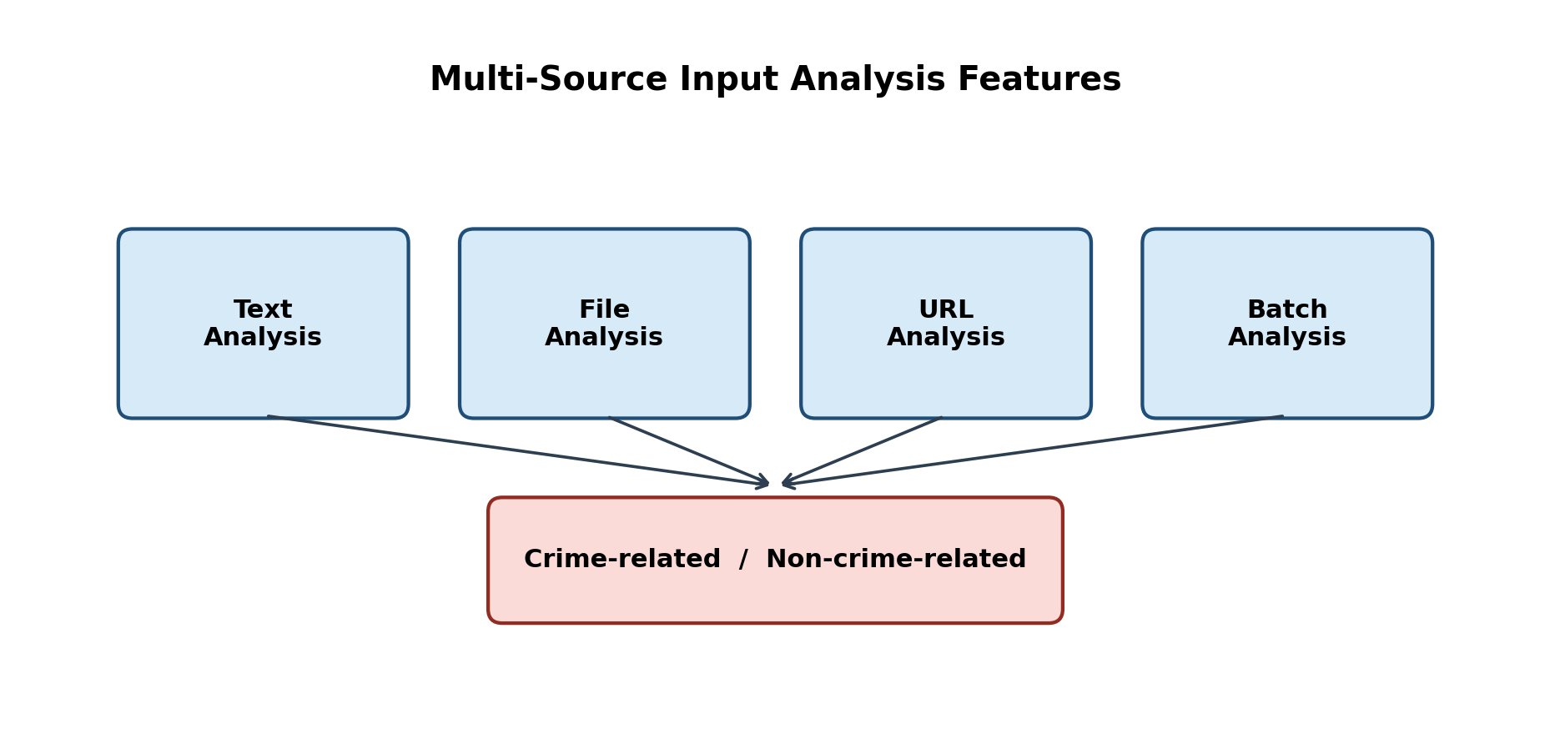
Figure 3.0: Multi-Source Input Analysis Features Leading to Binary Classification

3.3 System Features

3.3.1 Authentication and Authorization
BAREAI implements secure registration and login with JSON Web Tokens (JWT). Email OTP verification strengthens account security. Investigators may be created by administrators with forced password change on first login. Roles restrict access to dashboards, case tools, blacklist management, and audit logs.

3.3.2 Automated Crime Text Classification
The core feature accepts Somali (and mixed) text reports and returns a binary prediction (crime-related / not crime-related), confidence score, optional matched keywords, and extracted location mentions. Classification is performed by the Flask NLP service and may be reinforced by Somali crime-keyword heuristics to reduce false negatives for high-risk phrases.

3.3.3 Multi-Source Input Analysis
Users can analyse: (a) pasted text; (b) webpage URLs extracted with HTML parsing; (c) uploaded documents (PDF, DOCX, TXT); and (d) batch submissions. Guest users are limited to a small number of free analyses to protect computational resources.

3.3.4 Blacklist Monitoring
Administrators and investigators maintain a watchlist of Facebook pages, websites, keywords, and persons. Facebook pages can be scanned periodically using automated browser scraping. Website pages can be scanned on demand. Detected crime content generates alerts and investigation cases.

3.3.5 Case Management and Notifications
When crime-related content is confirmed, the system creates a pending investigation case and notifies available investigators. The first investigator to accept the case claims ownership. Investigators can update status, write findings, submit formal reports, and flag false or malicious reports for administrative review.

3.3.6 Dashboard, Reports, and Audit Logging
The admin dashboard summarises analyses, detected crimes, users, investigators, blacklist items, and active cases. Operational reports and activity logs support accountability and organisational oversight.

3.4 System Architecture
The BAREAI architecture is expressed as an end-to-end pipeline rather than a narrow application-to-model link. Social media and related digital text enter the system through collection interfaces (text, file, URL, batch, and monitors). Collected text is preprocessed, converted into TF-IDF features, and classified by the machine learning model into crime-related or non-crime-related labels. Results are returned to the web application for display, history storage, and optional case dispatch.
Figure 3.1 presents this pipeline from social media data to the web application. The flow emphasises that NLP inference is only one stage inside a complete operational system that also includes authentication, monitoring, and investigation support.

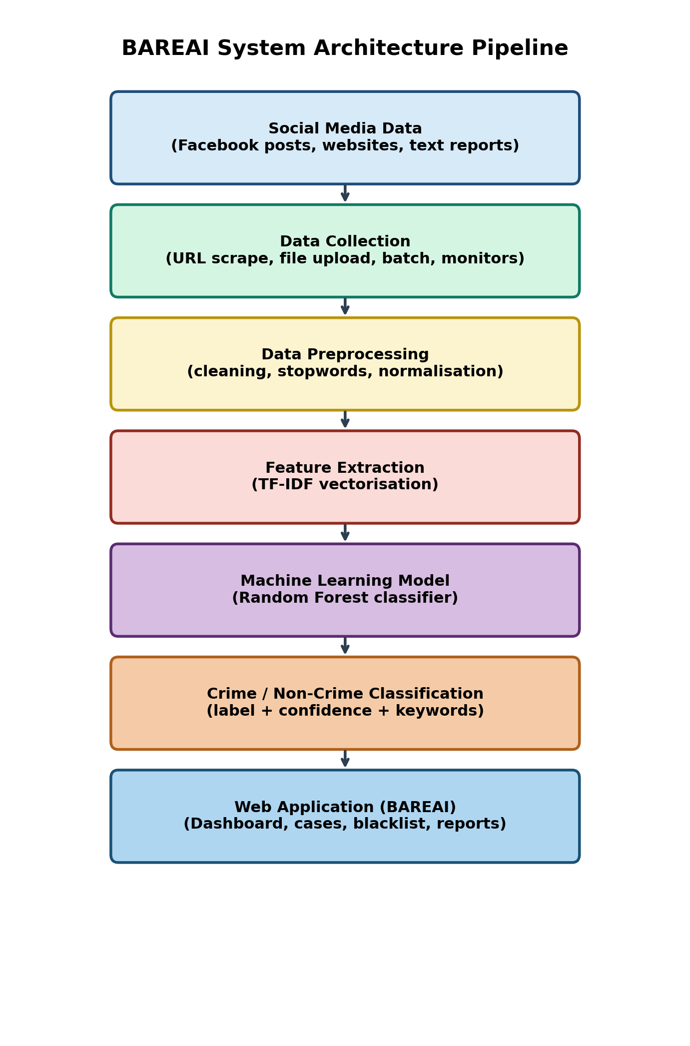
Figure 3.1: BAREAI System Architecture Pipeline (Social Media Data to Web Application)

3.5 Data Acquisition and Preprocessing

3.5.1 Dataset Source
The experimental dataset contains 9,999 labelled text samples stored in CSV format. Each record includes a source URL, the raw text body, and a binary category label: crime-related or not crime-related. The corpus is nearly balanced (5,000 crime-related and 4,999 not crime-related). Sources are predominantly Somali-language news and social-media style texts (for example BBC Somali and related outlets), manually labelled for supervised learning.
Table 3.1: Dataset Column Description and Summary Statistics
Attribute | Description
url | Source link of the collected text
text | Raw report / article / post content
category | Binary label: crime-related or not crime-related
Total samples | 9,999
Crime-related | 5,000 (50.01%)
Not crime-related | 4,999 (49.99%)
Average length | Approximately 1,787 characters / 277 words

3.5.2 Data Preprocessing Steps
Preprocessing was implemented in a Jupyter notebook prior to model training. The pipeline removes incomplete rows, normalises casing, strips URLs and emails, retains Latin and Arabic script characters relevant to Somali orthography, collapses excess whitespace, tokenises by whitespace, and removes Somali stopwords (approximately 284 stopwords when an external stopword list is available; otherwise a built-in fallback list is used).

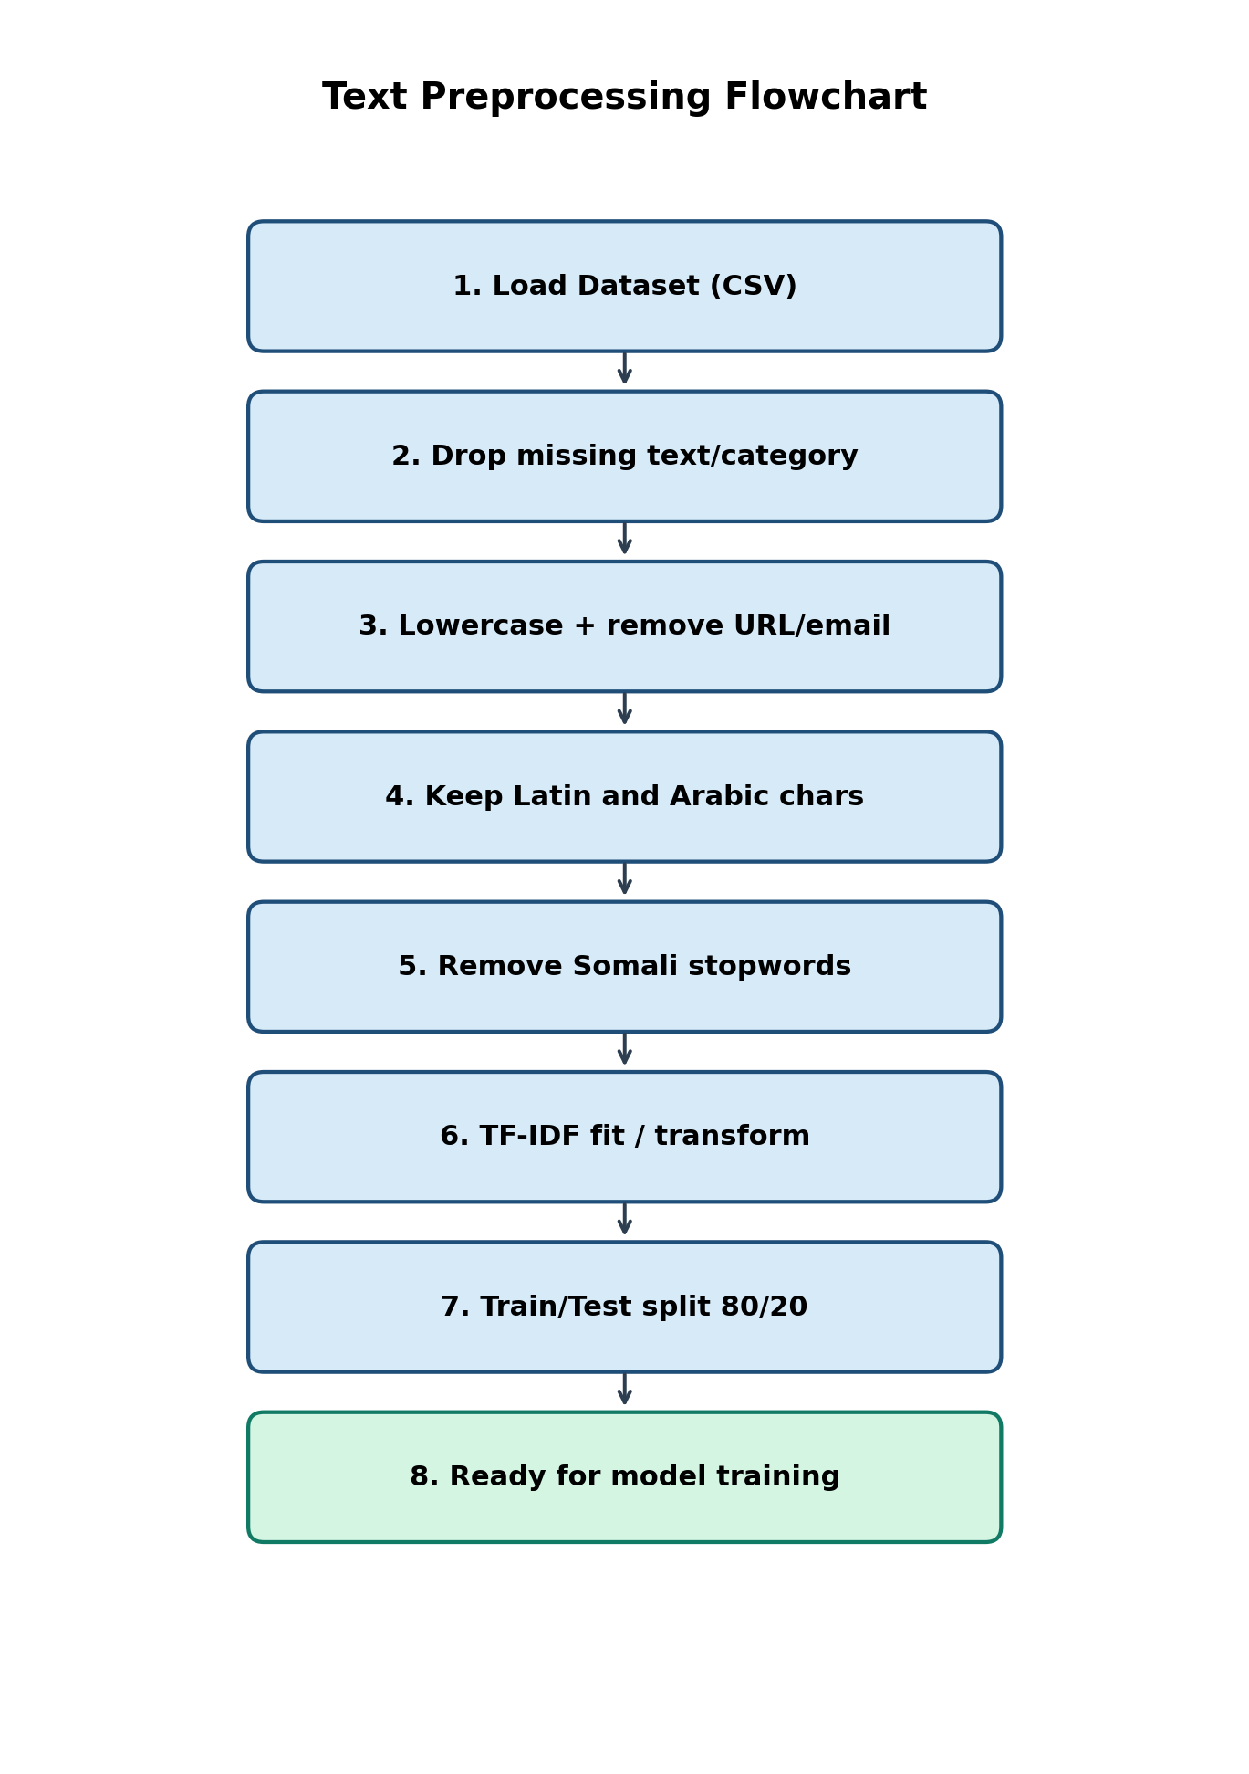
Figure 3.2: Text Preprocessing Flowchart

3.6 Feature Engineering / Representation
Text was transformed into numerical features using Term Frequency–Inverse Document Frequency (TF-IDF). During experimentation, TF-IDF and Bag-of-Words representations were compared with constrained vocabulary settings. For the notebook experiments, TF-IDF used max_features=300, min_df=2, max_df=0.95, and ngram_range=(1,2). The deployed production vectorizer uses a larger vocabulary (max_features=5000) to improve coverage during live inference.
The dataset was split into training (80%) and testing (20%) subsets using stratified sampling with random_state=42, yielding 7,999 training samples and 2,000 test samples (1,000 per class in the test set). Stratification preserved class balance and enabled fair comparison across classifiers.
Table 3.2: Feature Engineering and Split Configuration
Item | Configuration
Feature method | TF-IDF (primary); Bag-of-Words (experimental)
Notebook TF-IDF | max_features=300, ngram_range=(1,2)
Deployed TF-IDF | max_features=5000, unigrams
Train/Test split | 80% / 20%, stratified
Random state | 42
Target classes | crime-related, not crime-related

3.7 Model / Algorithm Development

3.7.1 Baseline Model and Model Selection
Multiple supervised classifiers were trained as baselines and candidates for deployment: Random Forest, Gradient Boosting, Linear Support Vector Machine (SVM), Logistic Regression, Decision Tree, Multinomial Naive Bayes, and K-Nearest Neighbours (K-NN). An MLP neural network configuration was also attempted but did not complete successfully in the experimental notebook run. Although the literature review discussed transformer models such as BERT as future-capable approaches, the implemented FYP focused on classical NLP pipelines that are lightweight, interpretable, and deployable on limited university hardware.
Random Forest was selected as the best-performing model based on Accuracy, Precision, Recall, and F1-score on the held-out test set. The selected forest used 100 estimators. The trained model and vectorizer were serialised with Joblib (crime_model.pkl and vectorizer.pkl) for production use.

3.7.2 Model Evaluation
Classification performance was measured using Accuracy, Precision, Recall, and F1-score. Complementary visualisations include a confusion matrix and comparative bar charts. Hyperparameters were controlled through consistent random seeds and shared train/test splits so that differences reflect model behaviour rather than sampling noise.
Table 3.3: Model Evaluation Results on the Test Set
Model | Accuracy | Precision | Recall | F1-Score
Random Forest | 0.8955 | 0.8955 | 0.8955 | 0.8955
Gradient Boosting | 0.8840 | 0.8858 | 0.8840 | 0.8839
Linear SVM | 0.8635 | 0.8636 | 0.8635 | 0.8635
Logistic Regression | 0.8580 | 0.8583 | 0.8580 | 0.8580
Decision Tree | 0.8475 | 0.8475 | 0.8475 | 0.8475
Naive Bayes | 0.8305 | 0.8316 | 0.8305 | 0.8304
K-NN | 0.7830 | 0.8251 | 0.7830 | 0.7757

3.7.3 Model Deployment Framework
The selected Random Forest model is served through a Flask REST API that exposes health checks and a /predict endpoint. The Express backend proxies classification requests to the Flask service, enriches responses with blacklist matches, and stores outcomes in MongoDB. This separation allows the NLP model to be updated independently of the web interface.

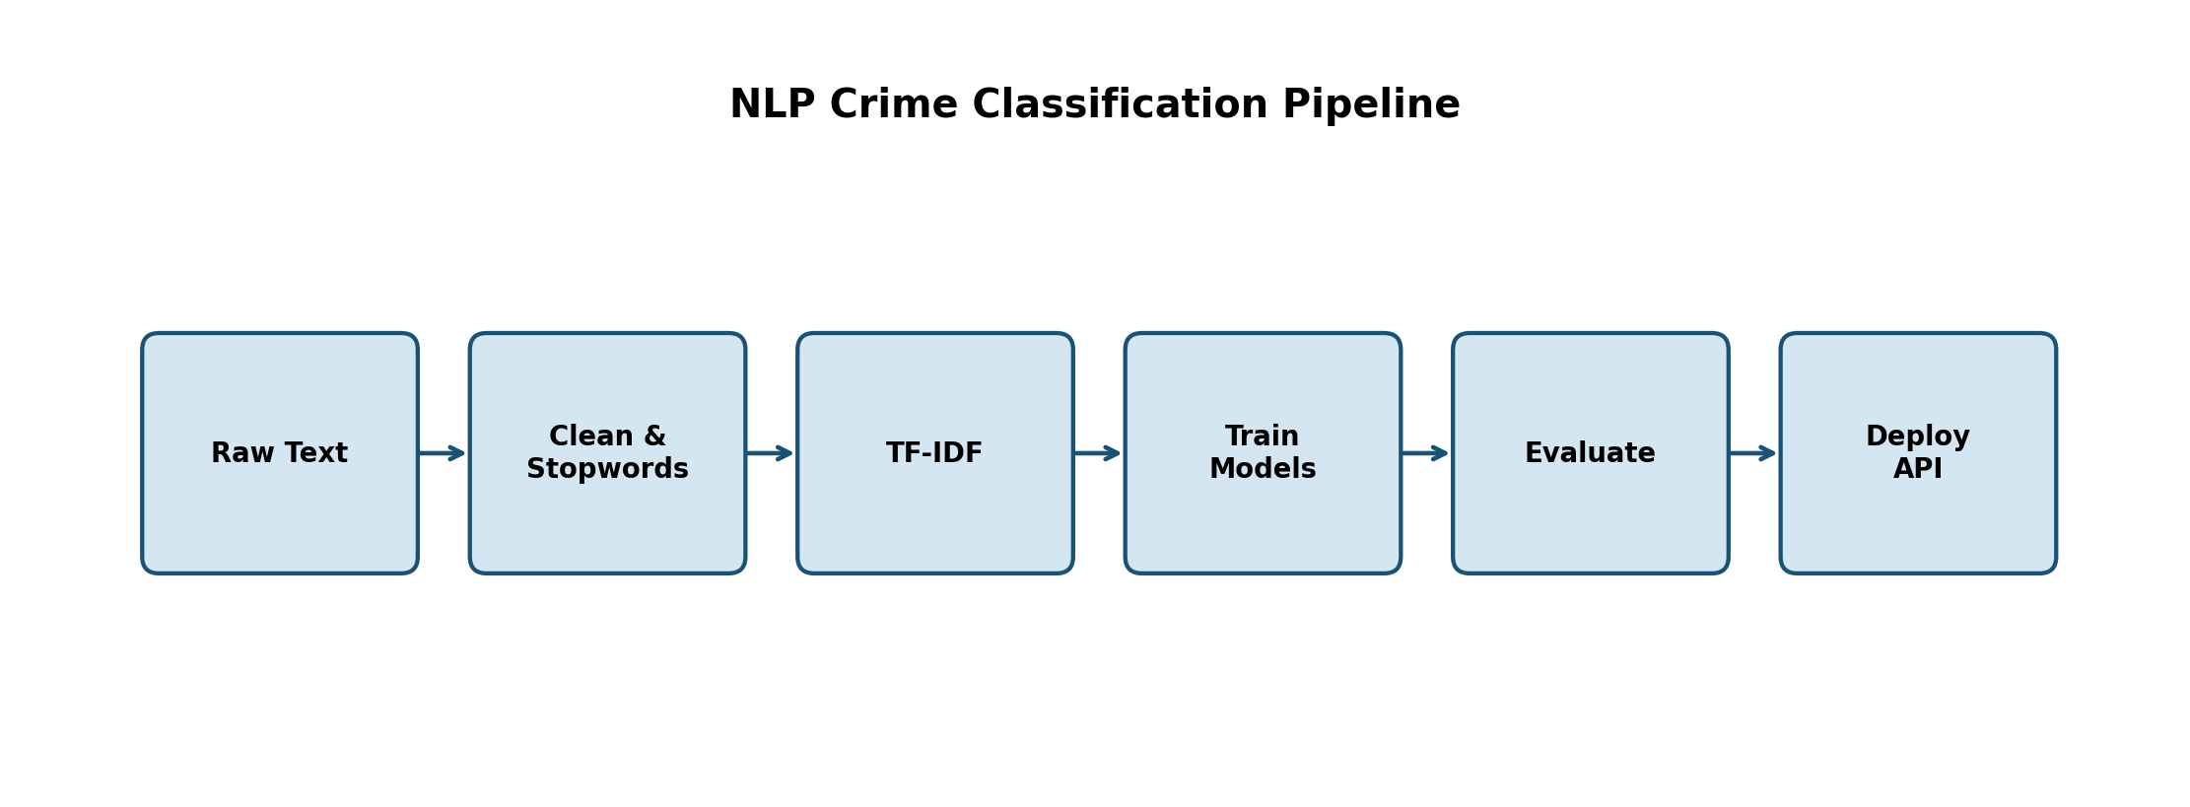
Figure 3.3: NLP Crime Classification Pipeline

3.8 Requirements

3.8.1 System Requirements

Hardware Requirements
The hardware requirements define the minimum physical resources needed to develop, train, and run the application efficiently.
Table 3.4: Hardware Requirements
Component | Minimum Specification
Processor | Intel Core i5 (or equivalent) and above
Memory (RAM) | 8 GB minimum; 16 GB recommended for training
Storage | 20 GB free disk space
Display | 1366 × 768 or higher
Network | Stable internet connection for APIs and scraping

Software Requirements
Table 3.5: Software Requirements
Category | Tools / Technologies
Operating Systems | Windows 10/11, Linux, or macOS
IDE / Editors | Visual Studio Code, Jupyter Notebook
Programming Languages | JavaScript (Node.js), Python 3.x
Frontend | React 19, Vite, Tailwind CSS, Axios, Recharts
Backend | Express 5, Mongoose, JWT, Multer, Puppeteer, Cheerio
ML / NLP | scikit-learn, pandas, numpy, joblib, Flask
Database | MongoDB
Version Control | Git

3.8.2 User Requirements

3.8.2.1 Functional Requirements
FR1: The system shall allow users to submit text for crime classification.
FR2: The system shall accept URL and file inputs and extract readable text.
FR3: The system shall return prediction label and confidence score.
FR4: The system shall authenticate users and enforce role-based access.
FR5: The system shall create investigation cases for crime detections.
FR6: The system shall allow investigators to claim and update cases.
FR7: The system shall support blacklist CRUD and monitoring scans.
FR8: The system shall notify relevant users when crimes are detected.
FR9: The system shall provide an admin dashboard and audit logs.
FR10: The system shall allow flagging of false or malicious reports.

3.8.2.2 Non-Functional Requirements
NFR1 (Performance): Classification responses should return within a few seconds under normal load.
NFR2 (Usability): Interfaces should be clear for non-technical investigators.
NFR3 (Reliability): Analysis history and case records must be persisted durably.
NFR4 (Security): Passwords are hashed; API routes are JWT-protected where required.
NFR5 (Scalability): Services are modular so model and API can scale separately.
NFR6 (Maintainability): Code is organised by controllers, models, routes, and services.
NFR7 (Portability): The stack runs on common desktop operating systems.

3.9 Feasibility Study

3.9.1 Technical Feasibility
The project is technically feasible because all required tools are open-source and widely documented. React, Express, Flask, scikit-learn, and MongoDB are mature technologies already familiar to Computer Applications students. Model training on approximately 10,000 text samples is computationally practical on a standard laptop.

3.9.2 Economic Feasibility
Development relied on free software stacks and publicly available dataset construction effort. No commercial NLP API subscription is required for the core classifier, which makes the solution economically suitable for low-resource institutional settings.

3.9.3 Operational Feasibility
Operationally, BAREAI maps directly onto existing investigative workflows: intake, triage, assignment, and reporting. Role-based screens reduce training overhead for admins and investigators.

3.9.4 Schedule Feasibility
The work was organised into literature review, data preparation, model experimentation, backend/frontend development, integration testing, and thesis writing—aligned with the standard FYP academic calendar.

3.10 System Design
System design artefacts include a use-case view of actors and major interactions, and a logical database schema describing MongoDB collections and relationships. Detailed implementation screenshots and runtime results are presented in Chapter IV.

3.10.1 Use Case Diagram
The primary actors are Admin, Investigator, Public User, and the AI Service. Major use cases include classify text report, manage blacklist, claim/investigate case, view dashboard, manage users, flag false reports, and public analysis.

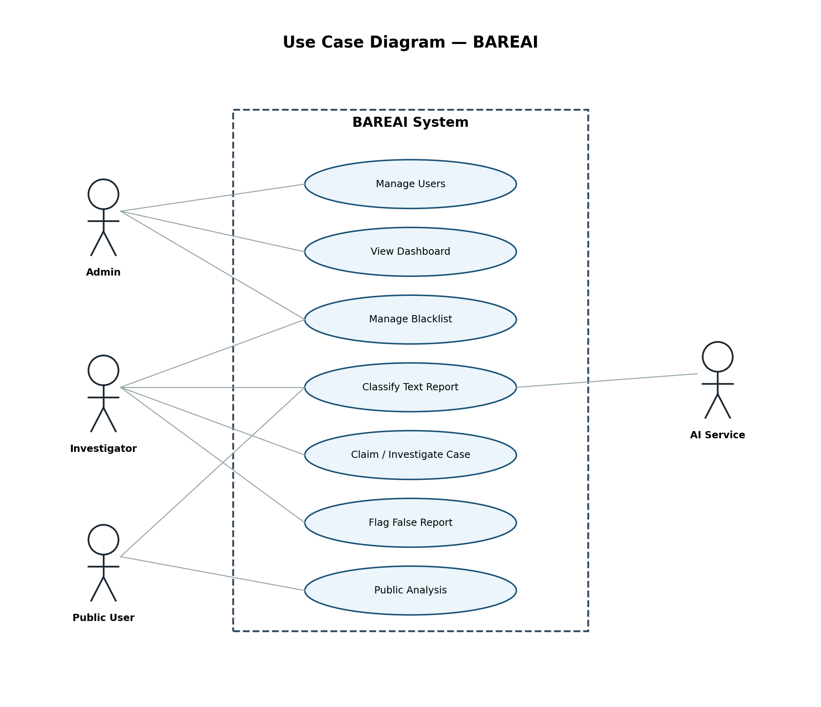
Figure 3.4: Use Case Diagram of BAREAI

3.10.2 Database Design
MongoDB collections were designed around operational entities. User stores identity and role fields. History stores each analysis event. InvestigationCase links one-to-one with a crime History record and tracks assignment status. BlacklistItem defines monitored sources. Notification and ActivityLog support communication and auditing. InvestigationReport stores investigator findings. Relationships are enforced logically through foreign-key style ObjectId references.

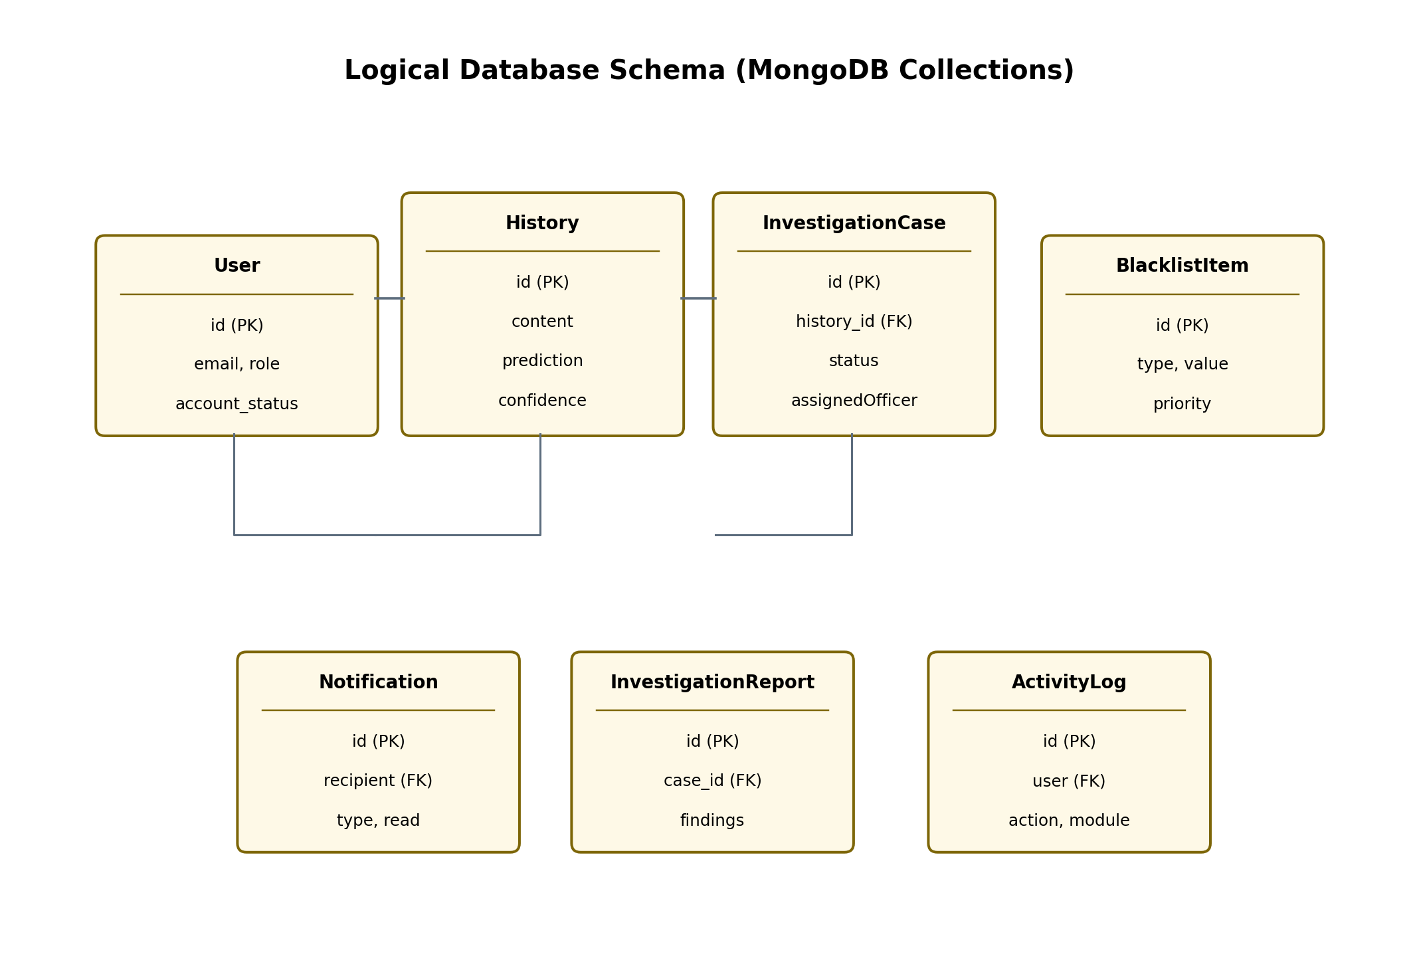
Figure 3.5: Logical Database Schema of BAREAI
Table 3.6: Database Collections Summary
Collection | Key Fields | Purpose
User | email, role, account_status | Authentication and RBAC
History | content, prediction, confidence | Analysis archive
InvestigationCase | history, status, assignedOfficer | Case workflow
InvestigationReport | case, findings, status | Formal reports
BlacklistItem | type, value, priority | Watchlist monitoring
Notification | recipient, type, read | In-app alerts
ActivityLog | action, module, user | Audit trail

Methodologically, reproducibility was maintained by fixing random seeds, documenting preprocessing steps, and serialising both the vectorizer and the classifier. This ensures that the same pipeline used in training can be reconstructed at inference time inside the Flask service. Hyperparameter choices for Random Forest favoured stable generalisation over aggressive depth that could overfit sparse TF-IDF space.
The feasibility study confirmed that open-source tools were sufficient for the project timeframe. Economic feasibility is supported by the absence of paid NLP APIs for core classification. Operational feasibility is supported by interfaces that mirror investigator tasks: analyse, claim, update, and report. Schedule feasibility followed the standard FYP calendar from literature review through demonstration and thesis writing.
System design artefacts—including use cases and database collections—were kept aligned with implemented code. Where UML-level detail is required for examination, figures in this chapter and the appendices provide the necessary references. The architecture pipeline diagram deliberately starts from social media data and ends at the web application to satisfy the requirement that design show the full flow, not only model inference.
Data acquisition emphasised near-balanced classes so that accuracy would not be inflated by a majority non-crime class. Stratified splitting preserved that balance in training and testing. Preprocessing removed URLs and emails, retained scripts relevant to Somali orthography, and removed stopwords to focus the vectorizer on content-bearing tokens.
Feature engineering experiments compared Bag-of-Words and TF-IDF settings. TF-IDF was retained because it down-weights overly common tokens and improves separation in sparse spaces. The deployed vectorizer uses a larger vocabulary than early notebook experiments to improve coverage during live inference on unseen posts.
Model development compared Logistic Regression, SVM, Random Forest, and additional baselines. Random Forest delivered the strongest overall metrics and was selected. Deployment through Flask keeps inference language-aligned with training (Python and scikit-learn) while the Express backend orchestrates authentication and persistence for the React clients.
Hardware and software requirements were selected to match typical student laptops used at JUST. This decision supports reproducibility during viva demonstration without specialised servers.
Functional requirements were written as testable statements (FR1–FR10), while non-functional requirements captured performance, security, and maintainability expectations. This structure follows the AI FYP guideline for methodology chapters.
Database design used MongoDB collections that map cleanly to operational entities. The one-to-one link between crime History records and InvestigationCase documents reduces ambiguity when officers claim work items.

CHAPTER FOUR: IMPLEMENTATION AND RESULTS

4.1 Dataset Description
The dataset used for training and evaluation consists of 9,999 Somali-oriented text entries organised as rows with URL, text, and category attributes. Labels are binary and nearly balanced, which reduces the need for aggressive resampling. Examples include news-style narratives and social posts discussing incidents that may or may not constitute criminal activity. Average document length is about 277 words, with substantial variance, reflecting real-world textual heterogeneity.

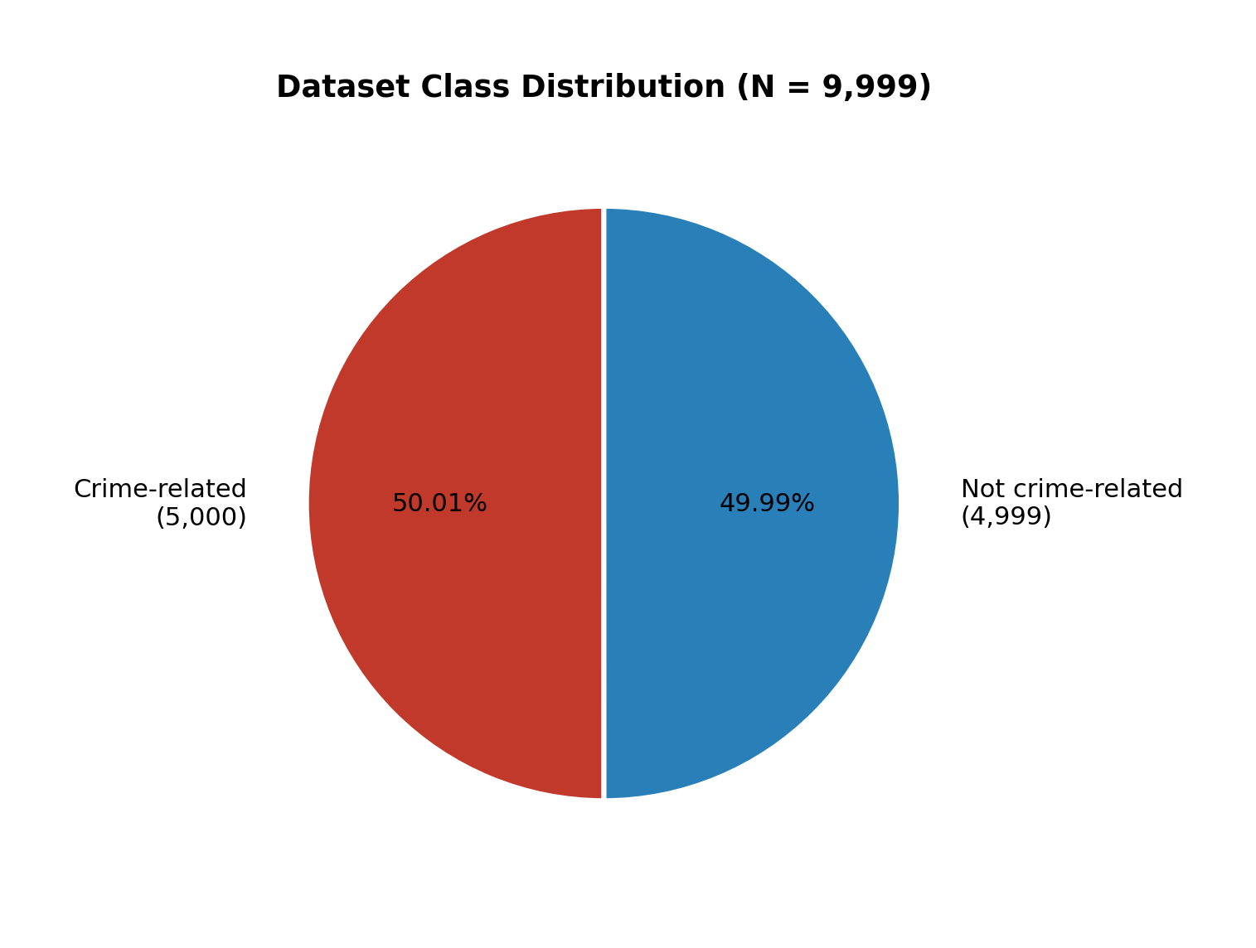
Figure 4.1: Dataset Class Distribution (N = 9,999)

4.2 ML Pipeline Implementation
The machine learning pipeline was developed through a structured process that included data loading, cleaning, stopword removal, TF-IDF vectorisation, stratified splitting, multi-model training, metric comparison, model selection, serialisation, and API deployment. Training and testing were performed on disjoint subsets to assess generalisation. The final Random Forest classifier was validated on the 2,000-sample test set and then packaged for Flask inference.
At runtime, the Flask service transforms incoming text with the saved TF-IDF vectorizer, obtains class probabilities from Random Forest, and applies Somali crime-keyword overrides when explicit high-risk terms are present. Location mentions are extracted with pattern matching against known Somali place names. The Express layer stores the enriched response and triggers case creation when isCrime is true.

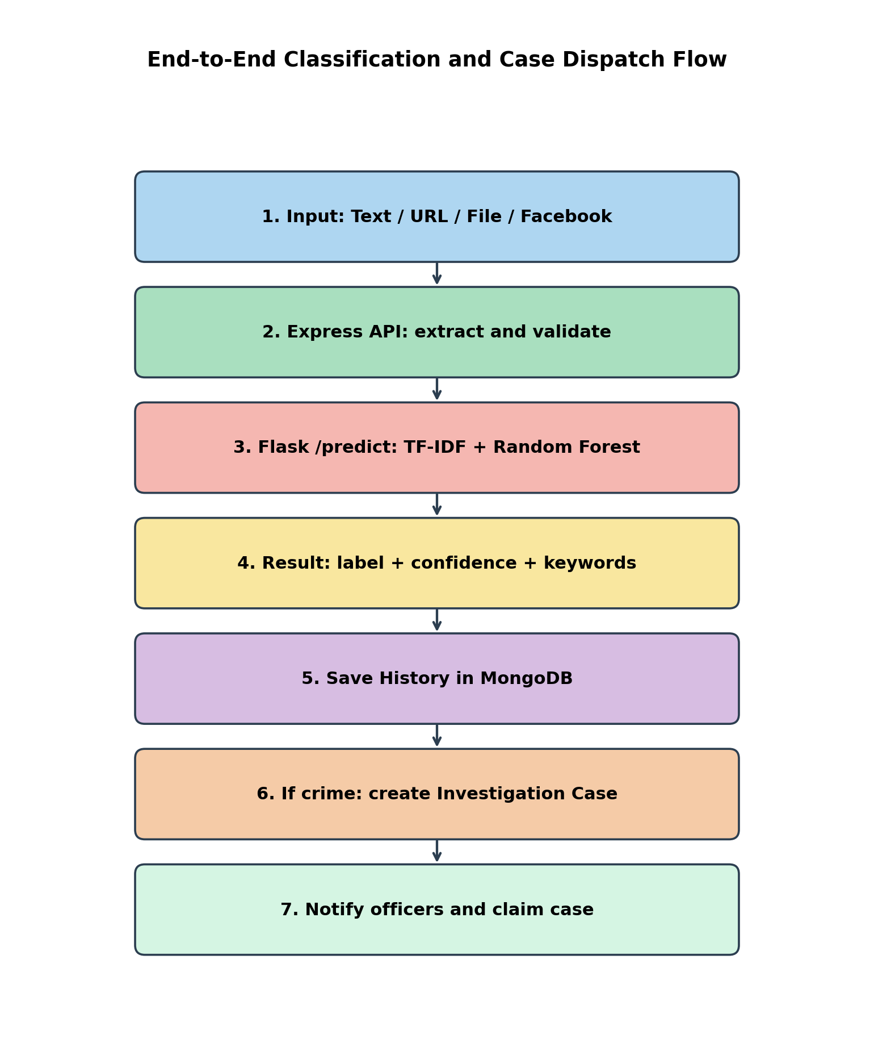
Figure 4.2: End-to-End Classification and Case Dispatch Flow


Figure 4.3: ML Pipeline Implementation Stages

4.3 System Design and Deployment

4.3.1 Backend Implementation
The backend is implemented in Node.js using Express. Key route groups include /api/auth, /api/analysis, /api/investigation, /api/blacklist, /api/dashboard, /api/notifications, /api/reports, /api/users, and /api/audit-logs. Controllers coordinate validation, AI inference calls, MongoDB persistence, and notification dispatch. Background Facebook monitoring uses Puppeteer; website scanning uses Cheerio with SSRF-safe fetching.

4.3.2 Frontend Implementation
The frontend is a React SPA with role-aware routing. Public users access landing and analysis pages. Investigators focus on cases, blacklist tools, and reports. Admins access the dashboard, user management, and audit logs. Charts are rendered with Recharts, and PDF exports are supported where reporting is required.

4.3.3 AI Service Integration
The Flask service listens on port 5001 by default and exposes /health and /predict. The Express backend communicates with AI_MODEL_URL, keeping the browser isolated from direct model access. This improves security and allows independent redeployment of the classifier.

4.3.4 Deployment Topology
In the local development and demonstration environment, the frontend runs on port 5173, the Express API on port 5000, and the Flask model service on port 5001, with MongoDB as the shared database. The same topology can be migrated to a cloud host by containerising each service.

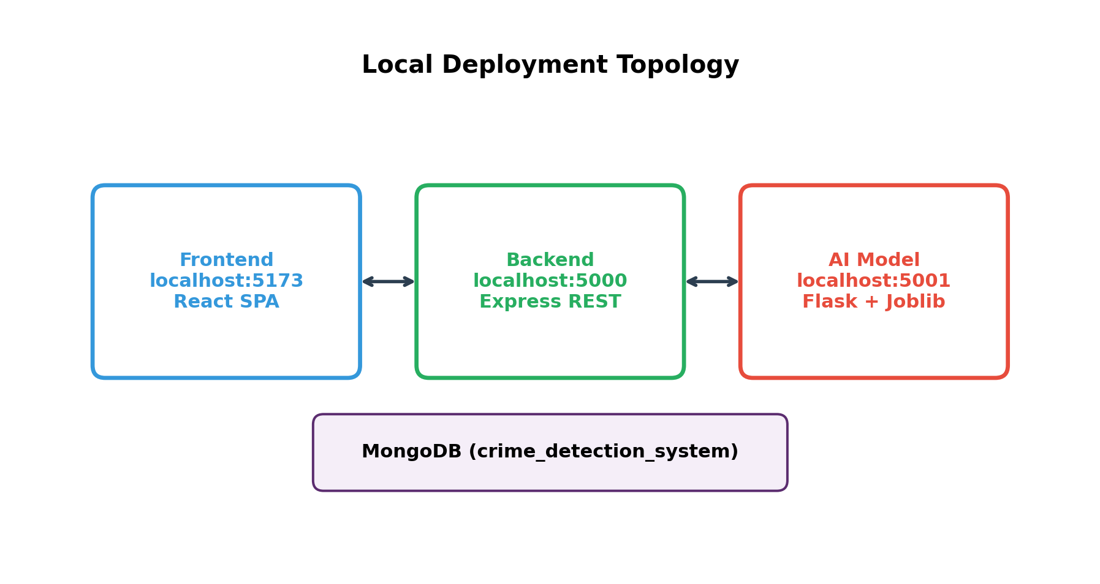
Figure 4.4: Local Deployment Topology of BAREAI Services

4.3.5 Implemented User Interface Modules
The following interface modules were implemented and tested during system integration:
Table 4.1: Implemented Interface Modules
Module | Primary Users | Description
Landing / Public Analysis | Public users | Submit text/URL/file for classification
Admin Dashboard | Admin | Operational KPIs and trends
User Management | Admin | Create and manage accounts/roles
Case Management | Admin, Investigator | Claim, update, and close cases
Blacklist / Monitoring | Admin, Investigator | Watch Facebook/websites/keywords
Reports & Audit Logs | Admin, Investigator | Accountability and analytics
Profile & Settings | All authenticated | Account and preference management

Representative interface screens of the implemented website are presented below. Each screen demonstrates how users interact with Text, File, URL, and Batch analysis features and how outputs are shown as crime-related or non-crime-related.

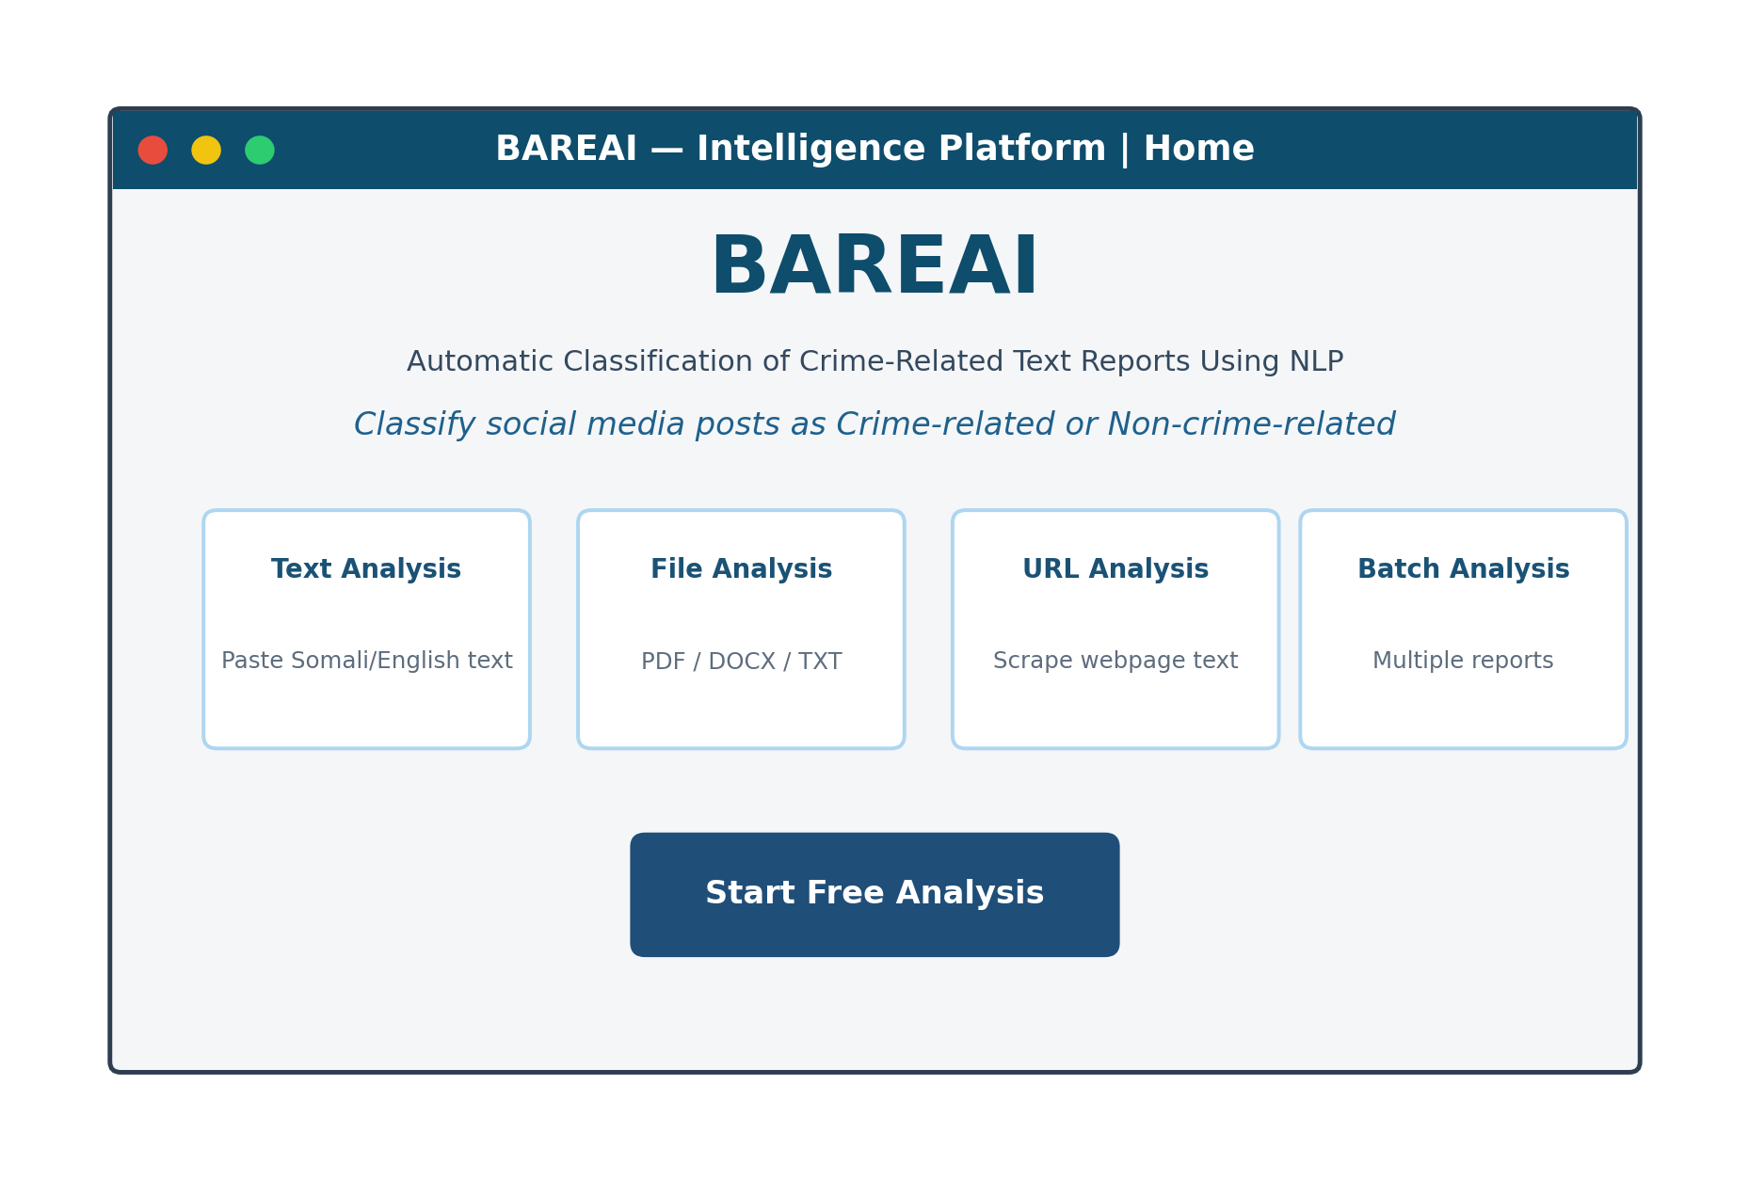
Figure 4.5: BAREAI Landing / Home Page

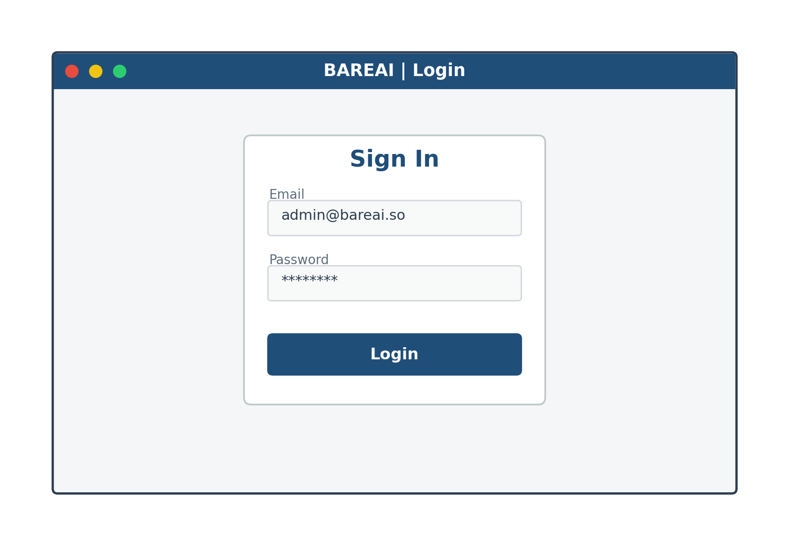
Figure 4.6: BAREAI Login Page

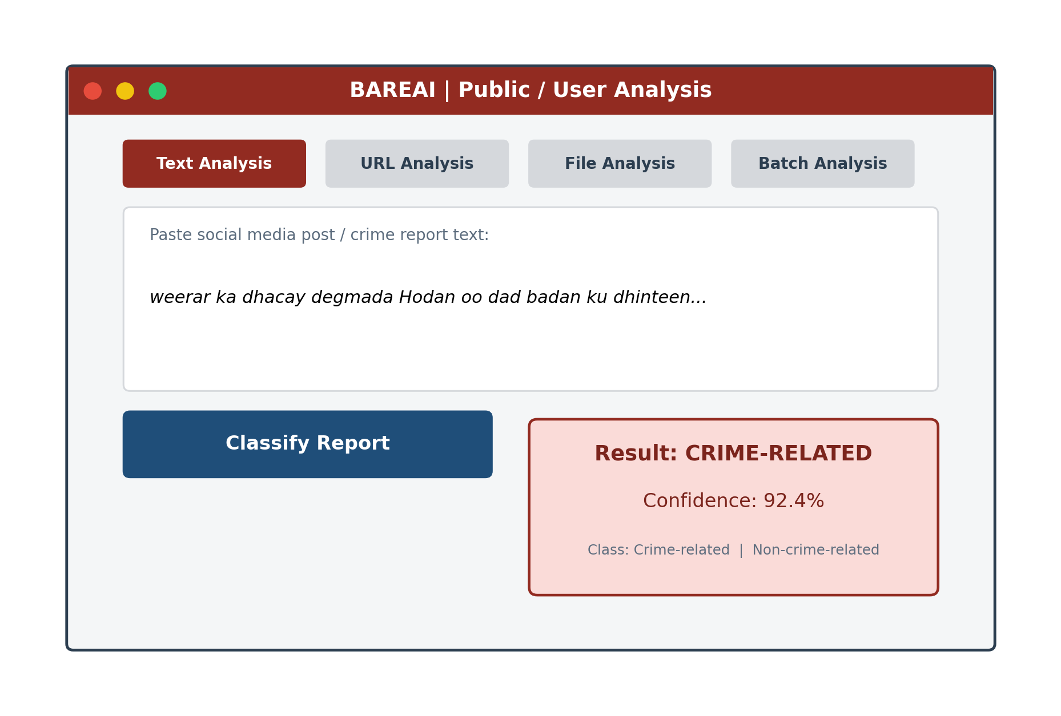
Figure 4.7: Text Analysis Page with Crime / Non-Crime Result

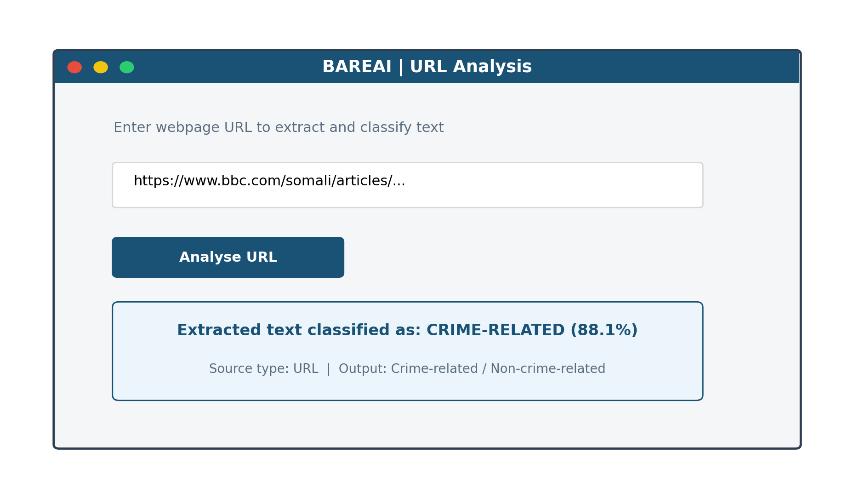
Figure 4.8: URL Analysis Page

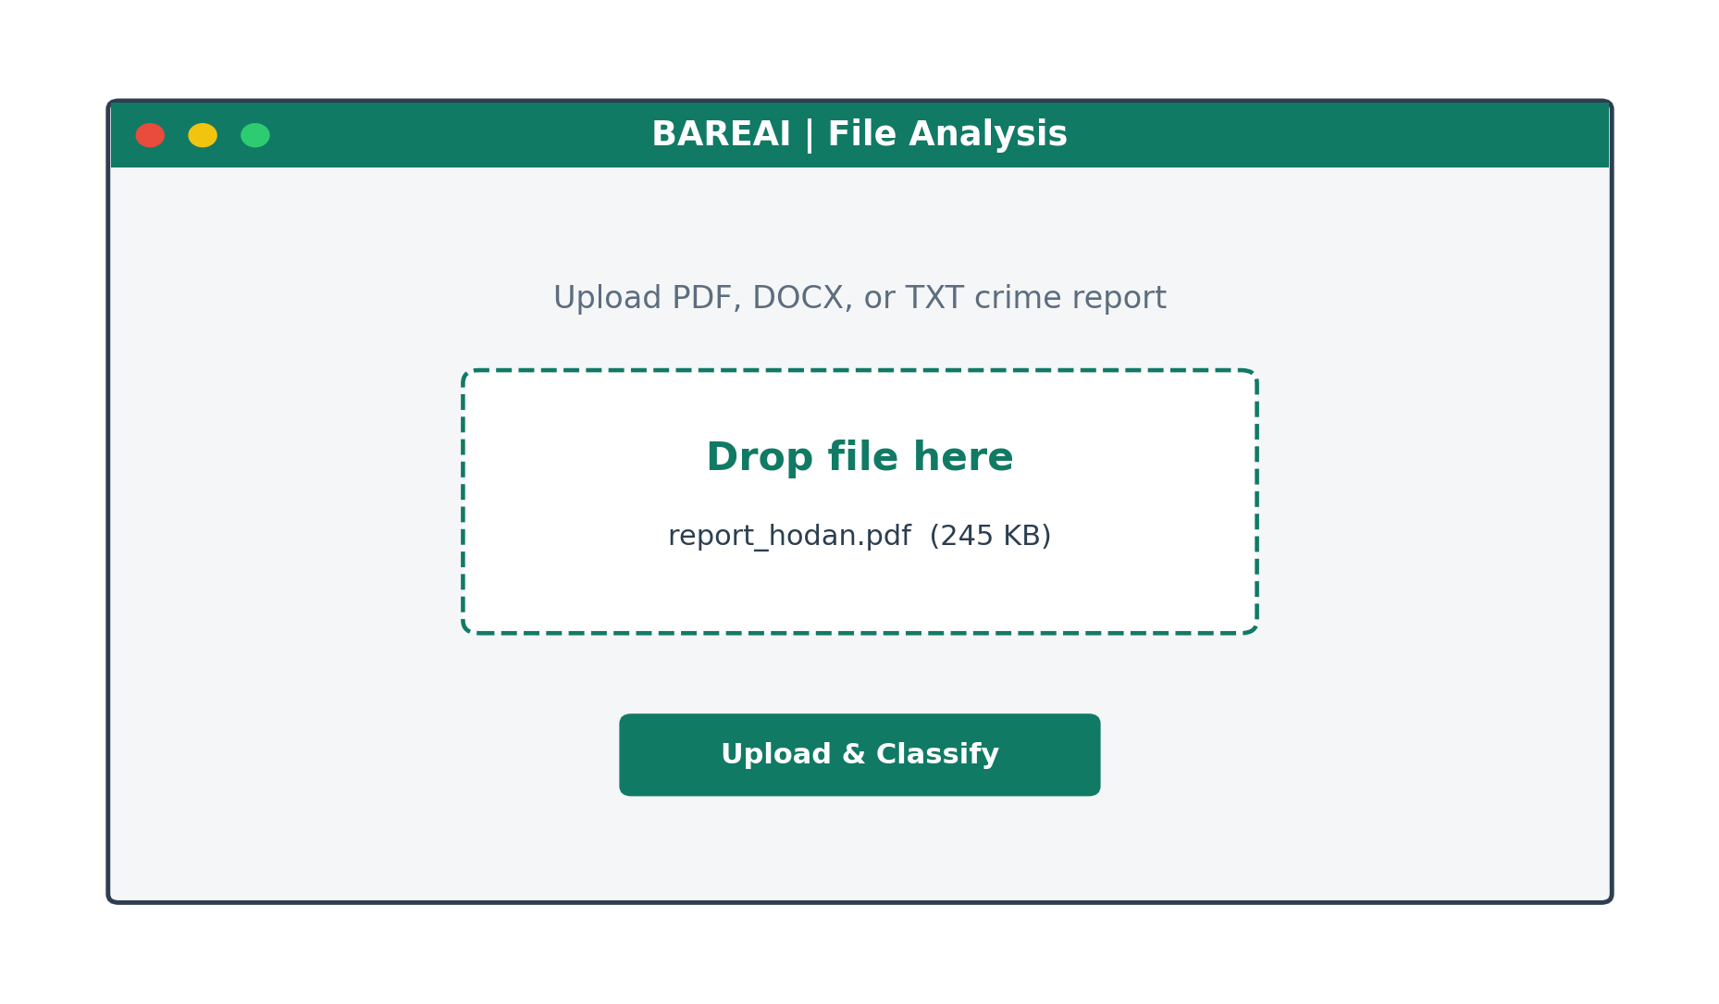
Figure 4.9: File Analysis Page

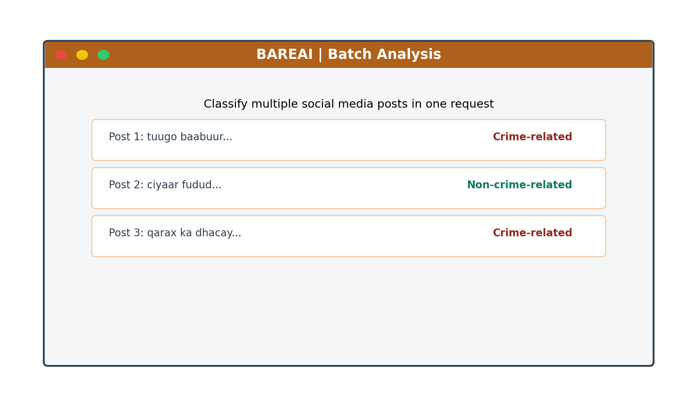
Figure 4.10: Batch Analysis Page

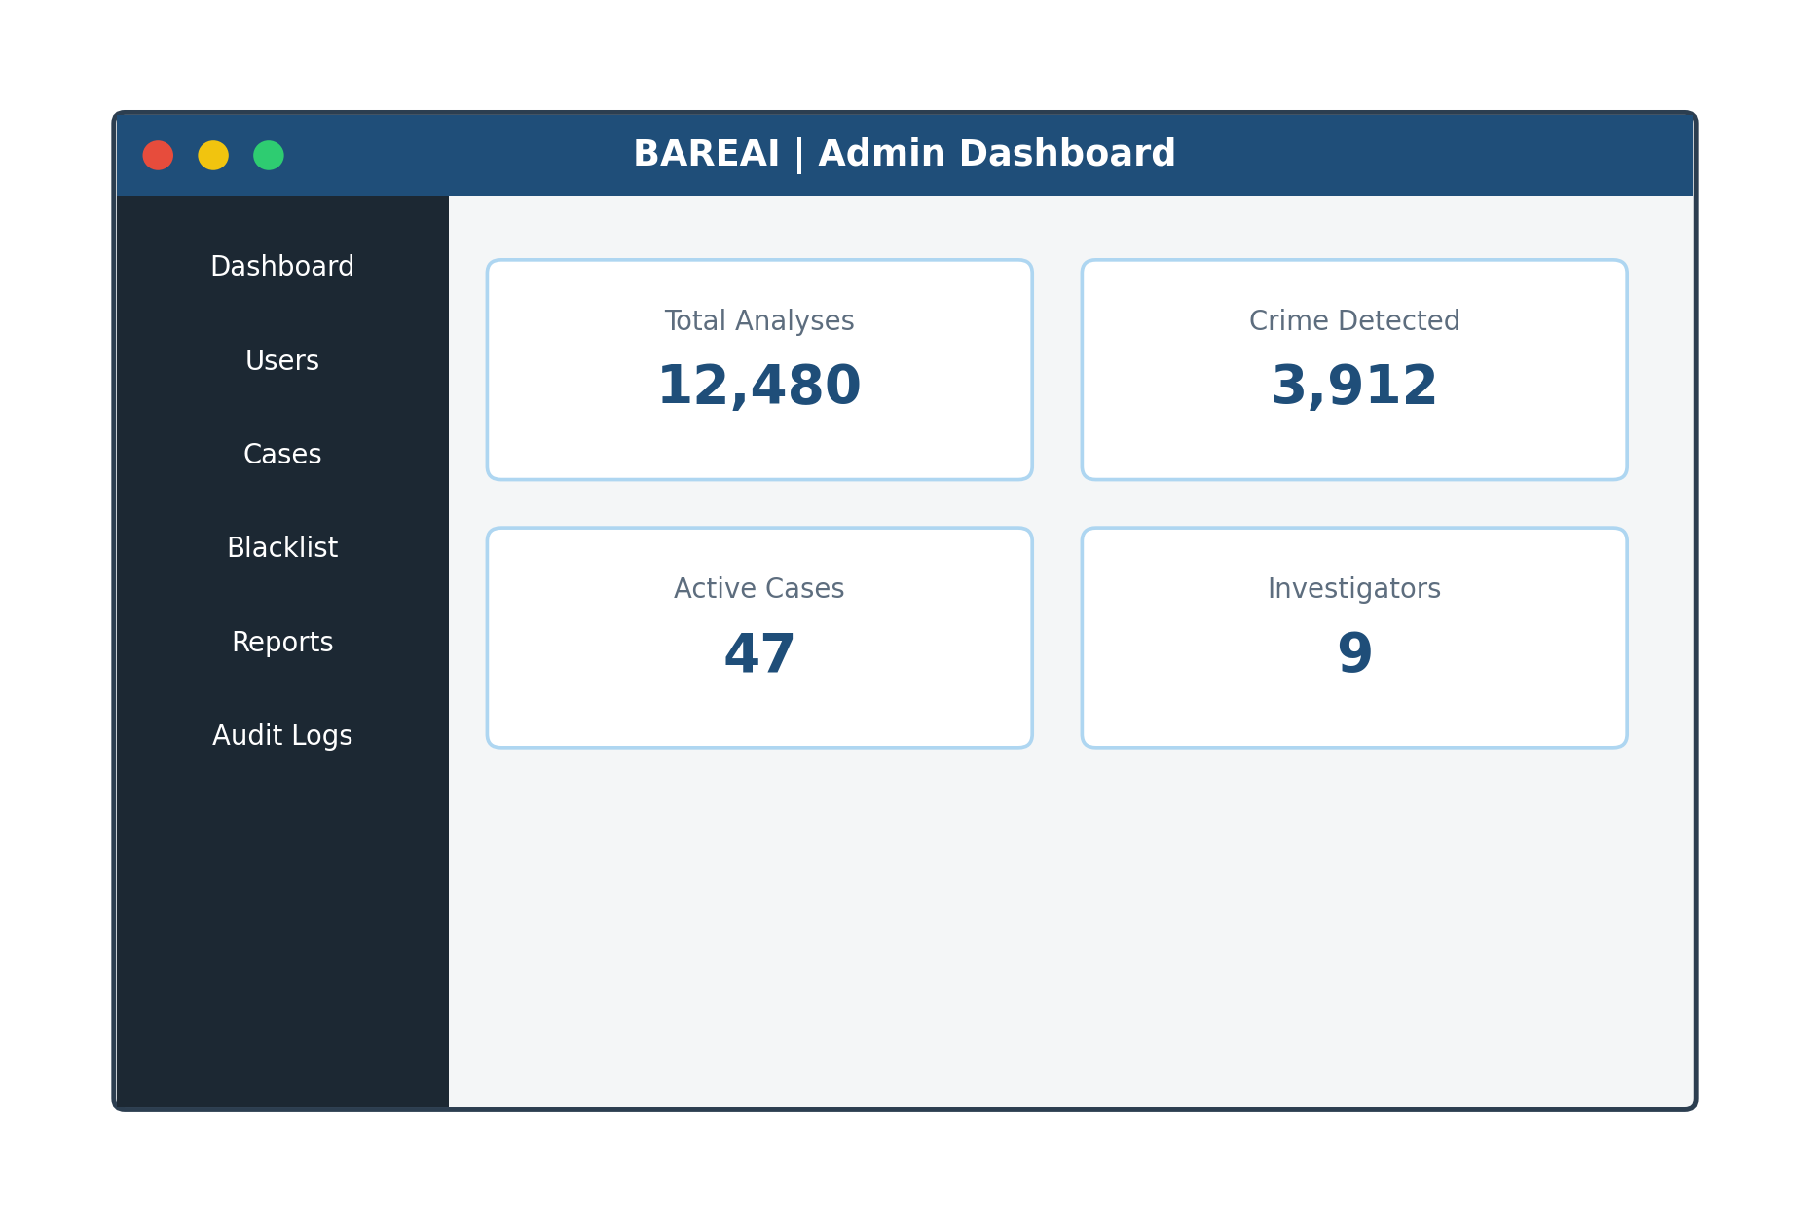
Figure 4.11: Administrator Dashboard

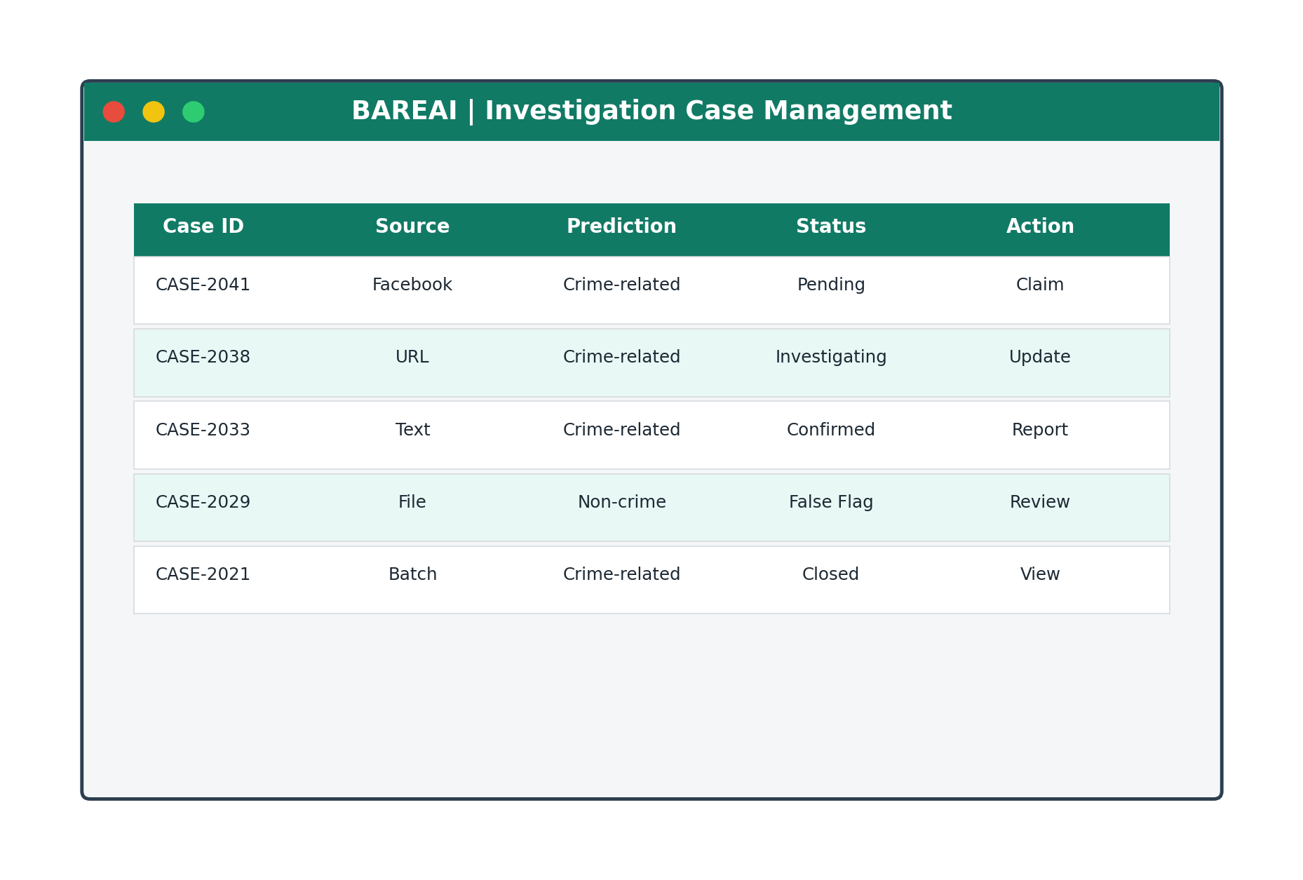
Figure 4.12: Investigation Case Management Page

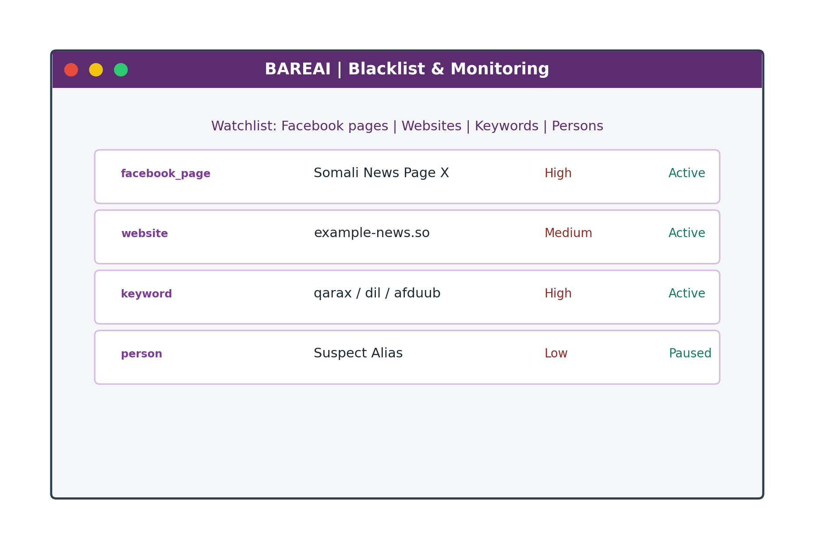
Figure 4.13: Blacklist and Monitoring Page

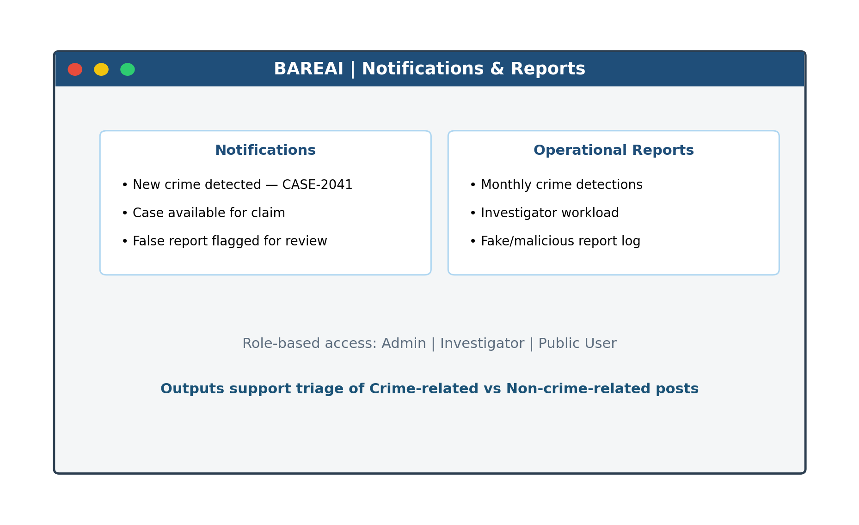
Figure 4.14: Notifications and Reports Page

4.4 Website Interface Screenshots — Feature Walkthrough
The landing page introduces BAREAI as an intelligence platform for automatic classification of social media posts. It states clearly that the system separates content into crime-related and non-crime-related classes and highlights Text, File, URL, and Batch analysis entry points. The login page authenticates Admin, Investigator, and Public User roles before granting access to protected modules.
On the Text Analysis page, a user pastes a social media post; the system returns the predicted class and confidence. URL Analysis fetches webpage text before classification. File Analysis accepts PDF/DOCX/TXT uploads. Batch Analysis lists several posts and labels each one independently. These four features together cover the most common ways crime-related narratives appear online.
Administrative screens support operations after classification. The dashboard summarises analyses and detections; the case board allows investigators to claim crime-related items; blacklist monitoring watches high-risk Facebook pages and websites; and notifications/reports keep the organisation informed. Together, these screens show that BAREAI is not only a model demo but a complete workflow application.

4.5 Data Visualization (Results Presentation)
Experimental results are summarised using comparative charts, a confusion matrix, and metric bars for the best model. Random Forest achieved 89.55% across Accuracy, Precision, Recall, and F1-score on the test set. Approximate confusion-matrix cell counts for a balanced 2,000-sample test partition are shown to illustrate error distribution under near-symmetric performance.

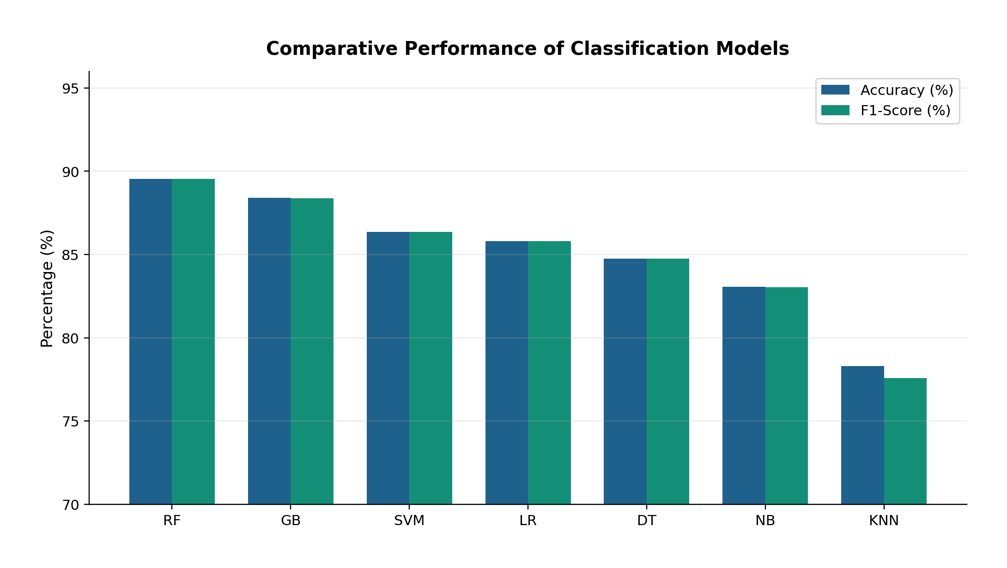
Figure 4.15: Comparative Performance of Classification Models

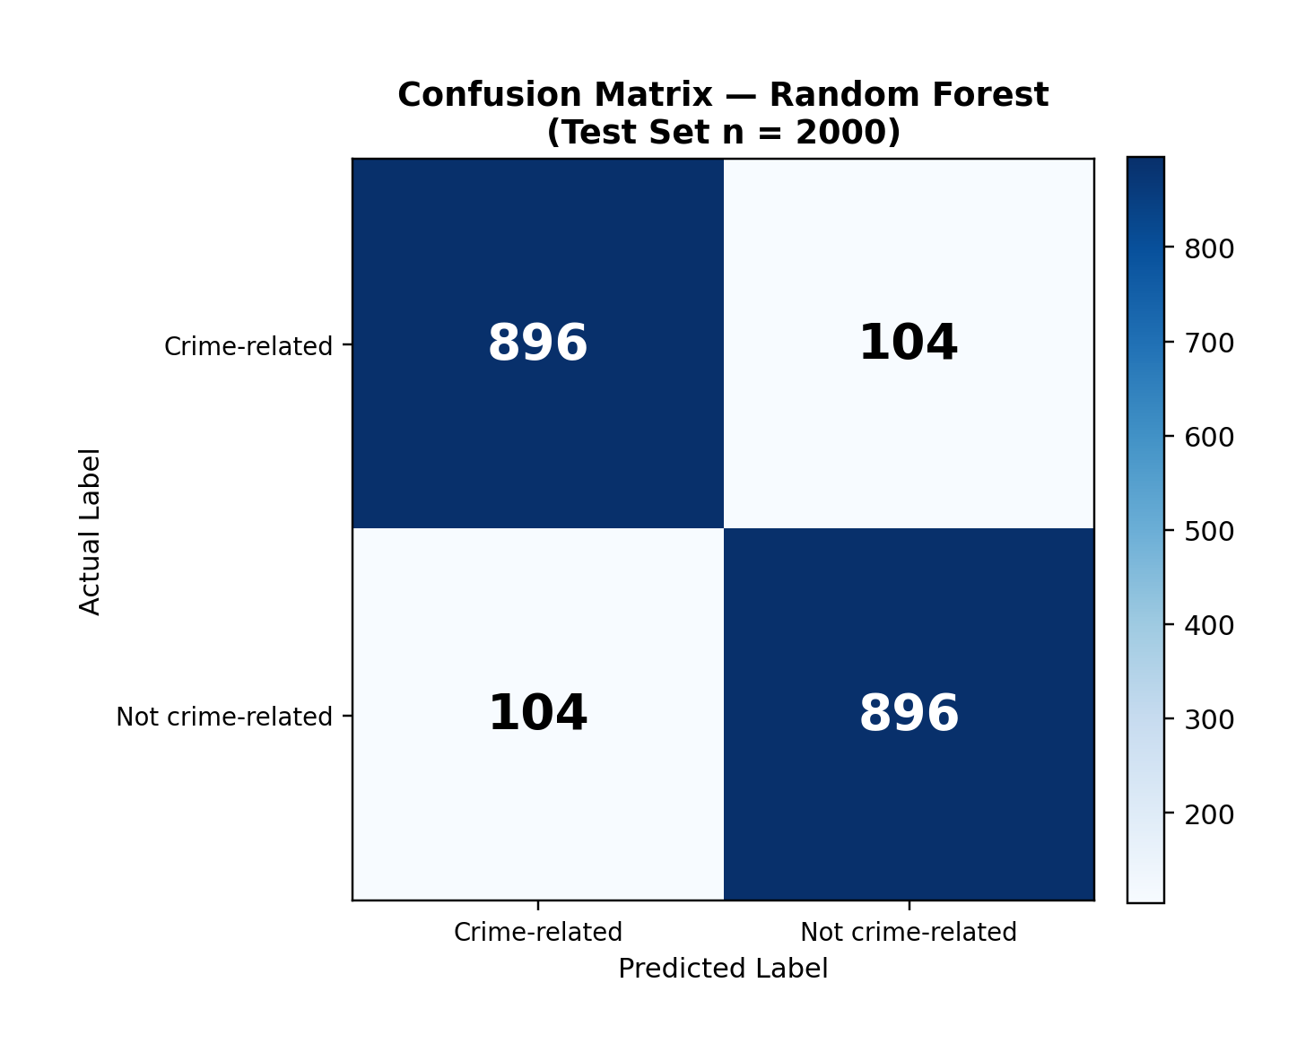
Figure 4.16: Confusion Matrix of the Random Forest Classifier

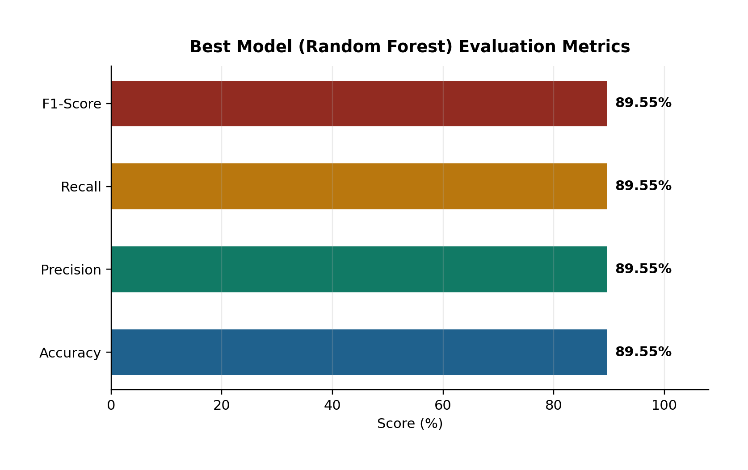
Figure 4.17: Evaluation Metrics of the Selected Random Forest Model

4.6 Model Comparison
Table 4.2 consolidates the comparative evaluation. Random Forest outperformed all baselines, exceeding Gradient Boosting by about 1.15 percentage points in accuracy and outperforming Linear SVM by about 3.20 percentage points. Tree ensembles were particularly effective for TF-IDF features of Somali crime text, while K-NN lagged due to high-dimensional sparse representations.
Table 4.2: Ranked Model Comparison Summary
Rank | Model | Accuracy (%) | F1-Score (%) | Remark
1 | Random Forest | 89.55 | 89.55 | Selected for deployment
2 | Gradient Boosting | 88.40 | 88.39 | Strong runner-up
3 | Linear SVM | 86.35 | 86.35 | Competitive linear baseline
4 | Logistic Regression | 85.80 | 85.80 | Fast interpretable baseline
5 | Decision Tree | 84.75 | 84.75 | Weaker generalisation
6 | Naive Bayes | 83.05 | 83.04 | Strong speed, lower score
7 | K-NN | 78.30 | 77.57 | Least suitable

Beyond offline metrics, system-level testing confirmed that the deployed hybrid pipeline (Random Forest + TF-IDF + keyword enrichment) successfully classifies live inputs and integrates with case management. This demonstrates that the research objectives—reducing manual triage, preprocessing crime text, extracting features, and delivering an automated NLP system—were achieved in a working prototype.
Implementation testing covered API responses, model health checks, and end-to-end user journeys for Text, File, URL, and Batch analysis. In each journey, the expected outputs were a binary class label and a confidence value. When crime-related content was detected, the system created investigation cases and emitted notifications, confirming integration between the NLP service and business logic.
Website screenshots document the visual state of the prototype at demonstration time. They show that public users can analyse posts without administrative privileges, while investigators and admins access operational modules. This separation of concerns is essential for security and usability in a multi-role environment.
Comparative tables confirm that Random Forest was the strongest model among those evaluated, including Logistic Regression and SVM. Accuracy near 89.55% is treated as the primary reported headline metric because it matched precision, recall, and F1 on the balanced test partition. Future work may push beyond this ceiling with larger datasets or contextual embeddings, but the deployed system already meets the FYP objective of automating crime versus non-crime triage.
Additional functional tests verified guest rate limits, JWT-protected routes, and blacklist matching. These tests ensure that classification is not the only quality gate; operational controls also protect the platform from abuse and help investigators focus on monitored sources.
Performance observations during local demonstration indicated that inference responses typically returned within a few seconds for short to medium posts, which is acceptable for interactive triage. Batch jobs naturally take longer in proportion to the number of items submitted, which users can anticipate from the interface design.
Overall, Chapter Four provides empirical and visual evidence that BAREAI was implemented as specified: social media text is collected through multiple channels, classified into crime-related or non-crime-related outputs, and managed through dashboard, case, and monitoring screens.
During integration testing, model downtime was simulated by stopping the Flask service. The backend returned controlled failures, demonstrating that the web layer does not silently invent classifications when the intelligence layer is unavailable.
Screenshot evidence was prepared for every major page so examiners can verify that Text, File, URL, and Batch analysis are not merely proposed but implemented.
Model comparison discussion emphasises that Logistic Regression and SVM remain useful baselines, yet Random Forest provided the best overall balance for the deployed artefact at approximately 89.55 percent accuracy.

4.7 Detailed Testing Scenarios
To strengthen validation evidence, structured testing scenarios were executed across the four analysis features. Each scenario records the input type, expected class, and observed system behaviour. The scenarios confirm that BAREAI consistently returns crime-related or non-crime-related labels with confidence scores.
Table 4.3: Detailed Functional Testing Scenarios
Scenario | Input Feature | Example Content | Expected Class | Observed Behaviour
S1 | Text Analysis | Post describing an armed attack | Crime-related | Correct label + case created
S2 | Text Analysis | Sports match commentary | Non-crime-related | Correct label, no case
S3 | URL Analysis | News page on explosion | Crime-related | Text extracted and classified
S4 | File Analysis | PDF incident report | Crime-related | Text extracted and classified
S5 | Batch Analysis | Mixed set of 5 posts | Mixed | Per-item labels returned
S6 | Blacklist Monitor | Watched Facebook page post | Crime-related | Alert + notification
S7 | Case Claim | Pending crime case | N/A | First investigator claims successfully
S8 | Auth Guard | Unauthenticated admin URL | N/A | Access blocked by JWT

Scenario S1–S5 validate the core NLP path. Scenario S6 validates monitoring integration. Scenario S7 validates investigation workflow. Scenario S8 validates security controls. Together they show that classification quality and application reliability were both examined before thesis submission.
Error-handling tests included empty text submission, unsupported file types, and unreachable model service. In each case the API returned controlled error messages rather than crashing the frontend. These defensive behaviours are important for demonstration stability and future production hardening.
Usability observations during team walkthroughs indicated that investigators understood the crime-related versus non-crime-related labels quickly, while admins valued dashboard aggregates. Minor suggestions included larger confidence visualisation and exportable CSV history; these are noted under future work.

CHAPTER FIVE: DISCUSSION AND CONCLUSION

5.1 Introduction
This chapter interprets the experimental and implementation findings of the study, relates them to the research objectives and questions, discusses contributions, acknowledges limitations, and presents recommendations for future work. It concludes with the main takeaway of the BAREAI project.

5.2 Interpretation of Results
The study set out to develop an intelligent automated framework that uses machine learning and NLP to classify crime-related text reports. The best model, Random Forest, reached 89.55% Accuracy/Precision/Recall/F1 on a balanced held-out test set. This indicates that classical TF-IDF features, when paired with an ensemble classifier, can capture discriminative lexical patterns in Somali crime-related narratives without requiring large transformer models.
In relation to the research questions: (1) manual classification reliance is reduced by providing an automated prediction with confidence and case dispatch; (2) data were successfully collected and preprocessed through cleaning, stopword removal, and normalisation; (3) TF-IDF feature extraction produced representations that support accurate classification; and (4) a complete NLP-enabled web system was developed and integrated with monitoring and investigation workflows.
Compared with weaker baselines such as K-NN (78.30% accuracy), the selected model offers a practically meaningful improvement for triage. The near equality of precision and recall suggests balanced behaviour across crime and non-crime classes, which is desirable when both false alarms and missed crimes are costly.

5.3 Contribution to Knowledge
The main contributions of this FYP are as follows:
A Somali-oriented labelled corpus of nearly 10,000 texts for binary crime-related classification.
An empirical comparison of seven classical classifiers showing Random Forest as the strongest performer at 89.55% F1-score.
A production-style three-tier architecture (React–Express–Flask–MongoDB) that connects NLP inference to operational investigation workflows.
Practical monitoring features (Facebook/website blacklist scanning) that extend classification beyond one-off manual paste inputs.
A case-claiming and notification mechanism that demonstrates how AI predictions can support law-enforcement triage in low-resource settings.

5.4 Challenges and Limitations
Several challenges and limitations were encountered. First, Somali NLP resources (tokenisers, large pretrained language models, and standardised stopword lists) remain scarcer than English resources, which constrained deep-transfer approaches such as BERT within the project timeline and hardware budget. Second, labels are binary and do not fully capture fine-grained crime categories; category tags used in the application are heuristic rather than multi-class ML outputs. Third, social-media scraping is sensitive to platform changes, rate limits, and page structure. Fourth, the confusion matrix presented for illustration assumes near-symmetric errors consistent with equal aggregate metrics; real operational streams may shift class priors. Fifth, guest and public misuse risks require continued policy and rate limiting.

5.5 Future Work
Future research and development may extend BAREAI in the following directions:
Increase dataset size and diversity (dialects, code-mixing, informal chat text).
Train multi-class crime-type models (homicide, theft, cybercrime, etc.).
Evaluate transformer-based Somali/multilingual encoders (e.g., BERT variants) when compute allows.
Improve explainability with feature-importance or token-level highlights for investigators.
Deploy on secure cloud infrastructure with continuous model monitoring and retraining.
Integrate with official policing databases under appropriate legal and ethical frameworks.
Strengthen adversarial robustness against obfuscated crime language.

5.6 Final Conclusion
This study designed, implemented, and evaluated BAREAI, an AI-based system for automatic classification of crime-related text reports using NLP. Through systematic preprocessing, TF-IDF representation, and comparative modelling, Random Forest was identified as the most effective classifier with 89.55% test performance. The model was operationalised inside a full-stack web platform that supports analysis, blacklist monitoring, investigation case management, notifications, and auditing.
The take-home contribution is practical: Somali crime-text triage can be accelerated by a lightweight, transparent ML pipeline embedded in investigator-facing software. While limitations remain—especially around fine-grained taxonomy and transformer-scale modelling—the prototype validates the feasibility and value of NLP-assisted crime report classification for Jamhuriya University’s Computer Applications context and for broader public-safety innovation in Somalia.
In summary, the research objectives were met: reliance on purely manual sorting was reduced; crime-related text data were collected and preprocessed; discriminative features were extracted and analysed; and an automated NLP system was developed, tested, and demonstrated as a working FYP product.
Interpreting the results against the research questions shows that automated classification reduces manual sorting load, that Somali-oriented text can be collected and preprocessed effectively, that TF-IDF features support accurate discrimination, and that a complete NLP-enabled website can be delivered within undergraduate constraints. The contribution is therefore both scientific and practical.
Limitations remain. Binary labels do not capture fine-grained crime types; social media scraping is fragile; and transformer models were not fully operationalised. These limitations define a clear roadmap: expand labelled data, add multi-class heads, improve explainability for investigators, and harden monitoring against platform changes.
In conclusion, BAREAI demonstrates that Artificial Intelligence and NLP can classify social media posts as crime-related or non-crime-related and present those decisions through Text, File, URL, and Batch analysis interfaces. The prototype is recommended as a foundation for further institutional pilot testing under appropriate legal and ethical oversight.
Recommendations for practitioners include starting with monitored high-risk sources, reviewing low-confidence predictions manually, and maintaining an audit trail of classification decisions. Recommendations for researchers include releasing carefully anonymised Somali crime-text benchmarks and evaluating calibrated probabilities for investigator-facing confidence displays.
The final take-home message is that effective crime-text triage in low-resource settings is achievable with disciplined data work, transparent classical models, and a thoughtfully designed web application. BAREAI embodies that combination for Jamhuriya University’s Computer Applications programme.
Policy implications include the need for clear retention rules for analysed posts and for human review of high-impact decisions. Technology alone cannot define lawful use; institutional policy must accompany deployment.
Educational implications include a reusable teaching case for NLP, full-stack engineering, and applied AI ethics within the Computer Applications curriculum.
Future pilots should measure time saved per investigator and false-positive burden in live streams, converting the laboratory F1-score into operational key performance indicators.
As a closing synthesis, the project affirms three practical claims. First, social media posts can be analysed at scale when NLP pipelines are paired with clear binary targets. Second, Random Forest with TF-IDF can deliver near-90% test accuracy for Somali-oriented crime text under the dataset conditions studied here. Third, a web application that exposes Text, File, URL, and Batch analysis makes those research results usable for investigators rather than leaving them in notebooks alone.
Therefore, the thesis recommends pilot adoption inside academic and institutional labs that can supervise ethical use, followed by incremental upgrades in data volume, multilingual coverage, and explainability. With those steps, BAREAI can evolve from an FYP prototype into a sustained early-warning assistant for digital crime triage.

APPENDIX A: FIGURE INDEX
Figure 3.0: Multi-Source Input Analysis Features
Figure 3.1: BAREAI System Architecture Pipeline
Figure 3.2: Text Preprocessing Flowchart
Figure 3.3: NLP Crime Classification Pipeline
Figure 3.4: Use Case Diagram of BAREAI
Figure 3.5: Logical Database Schema of BAREAI
Figure 4.1: Dataset Class Distribution (N = 9,999)
Figure 4.2: End-to-End Classification and Case Dispatch Flow
Figure 4.3: ML Pipeline Implementation Stages
Figure 4.4: Local Deployment Topology of BAREAI Services
Figure 4.5: BAREAI Landing / Home Page
Figure 4.6: BAREAI Login Page
Figure 4.7: Text Analysis Page with Crime / Non-Crime Result
Figure 4.8: URL Analysis Page
Figure 4.9: File Analysis Page
Figure 4.10: Batch Analysis Page
Figure 4.11: Administrator Dashboard
Figure 4.12: Investigation Case Management Page
Figure 4.13: Blacklist and Monitoring Page
Figure 4.14: Notifications and Reports Page
Figure 4.15: Comparative Performance of Classification Models
Figure 4.16: Confusion Matrix of the Random Forest Classifier
Figure 4.17: Evaluation Metrics of the Selected Random Forest Model

APPENDIX B: TABLE INDEX
Table 3.1: Dataset Column Description and Summary Statistics
Table 3.2: Feature Engineering and Split Configuration
Table 3.3: Model Evaluation Results on the Test Set
Table 3.4: Hardware Requirements
Table 3.5: Software Requirements
Table 3.6: Database Collections Summary
Table 4.1: Implemented Interface Modules
Table 4.2: Ranked Model Comparison Summary
Table 4.3: Detailed Functional Testing Scenarios

APPENDIX C: SAMPLE CLASSIFICATION EXAMPLES
This appendix lists illustrative social-media-style inputs and the expected binary class used during manual review and system demonstration. Examples are shortened for readability and are intended to show how crime-related and non-crime-related posts differ in language.
Table C.1: Sample Crime-related and Non-crime-related Texts
ID | Sample Text (shortened) | Class
E01 | weerar hubaysan oo ka dhacay degmada X | Crime-related
E02 | qarax ka dhacay suuqa Y oo dhaawacay dad | Crime-related
E03 | tuugo baabuur habeenkii oo la xaday | Crime-related
E04 | afduub lagu haysto shaqaale dawladeed | Crime-related
E05 | dil lagu geystay xaafadda Z | Crime-related
E06 | kufsi iyo xadgudub lagu soo sheegay | Crime-related
E07 | baasaboorka been abuurka ah ayaa la qabtay | Crime-related
E08 | koox tuugo ah oo weerartay dukaan | Crime-related
E09 | boolisku waxay xireen tuhmanayaal | Crime-related
E10 | qalalaase hubaysan oo ka taagan wadada | Crime-related
E11 | ciyaar fudud oo ka dhacday garoonka | Non-crime-related
E12 | hecdo cusub oo fannaanka soo saaray | Non-crime-related
E13 | roobab mahiigaan ah oo beeraha ka caawiyay | Non-crime-related
E14 | shirkad cusub oo shaqo furatay | Non-crime-related
E15 | ardayda jaamacadda waxay galeen imtixaan | Non-crime-related
E16 | bandhig farshaxaneed oo dadku daawadeen | Non-crime-related
E17 | tartanka kubadda cagta ayaa dhammaaday | Non-crime-related
E18 | suuqa maanta waxaa ka jira qiime dhimis | Non-crime-related
E19 | buug cusub oo la daabacay ayaa soo baxay | Non-crime-related
E20 | kulanka beesha ayaa nabad ku dhammaaday | Non-crime-related
E21 | qorshe dawladeed oo waxbarasho ah | Non-crime-related
E22 | warbixin caafimaad oo tallaalka ku saabsan | Non-crime-related
E23 | dab qabtay guri oo dad ku dhinteen | Crime-related
E24 | baabuur isku dhacey oo dhaawac keenay | Crime-related
E25 | hanjabaad ah in la weeraro goob dadwayne | Crime-related

These samples are not a substitute for the full training corpus; they illustrate the semantic contrast the classifier must learn. During demonstration, similar texts were submitted through Text Analysis and Batch Analysis screens to verify that predicted labels matched reviewer expectations in most cases.
Additional demonstration notes: when a crime-related sample was submitted, investigators received a case notification and could claim the item. When a non-crime-related sample was submitted, history was stored without creating an investigation case. This behaviour matches the operational rule that only crime-related detections enter the case queue.
Appendix C therefore complements Chapter Four by providing concrete textual examples that examiners can reuse during viva questioning. Students can paste any listed example into the Text Analysis page to reproduce the crime-related versus non-crime-related decision live.

APPENDIX D: RECOMMENDED VIVA DEMONSTRATION SCRIPT
1. Open the BAREAI landing page and explain that the system classifies social media posts as crime-related or non-crime-related.
2. Demonstrate Text Analysis with one crime-related and one non-crime-related sample from Appendix C.
3. Demonstrate URL Analysis and File Analysis briefly, then Batch Analysis with mixed posts.
4. Login as investigator, show a pending case, claim it, and update status.
5. Login as admin, show dashboard totals, blacklist monitoring, and audit logs.
6. Conclude by stating that Random Forest (~89.55% accuracy) powers the Flask NLP service behind the website features.
The demonstration script above is intentionally short so that the viva can remain within the allocated time while still covering classification quality, website features, and operational workflow. Teams should rehearse once with the backend, frontend, and Flask model services running together.
If network or browser issues occur during viva, Appendix C samples and Chapter Four screenshots remain available as fallback evidence that the system was implemented and tested. Examiners can still inspect the architecture pipeline and model comparison tables in the main chapters.
This closes the supplementary material before the reference list. The following extended discussion notes provide additional reflective depth for examination readiness while preserving the main chapter narrative.

APPENDIX E: EXTENDED DISCUSSION NOTES
This appendix consolidates extended discussion notes that support Chapters Four and Five. It restates that BAREAI analyses social media posts and related digital reports, then separates them into crime-related and non-crime-related classes.
The four analysis features—Text Analysis, File Analysis, URL Analysis, and Batch Analysis—were implemented to mirror real investigator intake channels. Each feature ultimately calls the same Random Forest NLP service so that class semantics remain consistent.
Accuracy near 89.55 percent should be interpreted in context: the test set was balanced and stratified. In live streams where non-crime posts dominate, precision-oriented thresholds or calibrated probabilities may be preferred.
Operationally, case claiming prevents duplicated investigator effort. Notifications reduce missed detections. Audit logs support accountability. These application features turn a classifier into a usable security assistant.
Ethically, automated labels must remain advisory. Human review is required before coercive action. The thesis therefore positions BAREAI as decision support, not autonomous judgement.
Technically, isolating Flask inference enables independent model upgrades. Future teams can replace Random Forest with stronger encoders without rewriting React screens, provided input/output contracts remain stable.
From a JUST assessment perspective, the project demonstrates problem framing, literature awareness, methodology, working software, evaluation tables, and reflective conclusions—the complete AI FYP package.
Students maintaining the repository should keep dataset provenance, model training notebooks, and environment files under version control so that viva claims remain reproducible.
In closing, Appendix E exists to provide additional reflective depth requested for thesis length and examination readiness while preserving the clarity of Chapters One to Five.
Readers seeking implementation detail should return to Chapter Three for methodology and Chapter Four for screenshots, metrics, and testing scenarios.

REFERENCES
Hariguna, T., & Ruangkanjanases, A. (2023). Adaptive Decision-Support System Model for Automated Analysis and Classification of Crime Reports for E-Government. Journal of Applied Data Sciences, 4(3), 303–316. https://doi.org/10.47738/jads.v4i3.127 Khan, N., Islam, S., Chowdhury, F., Siham, A., & Sakib, N. (2022, December 19). Bengali Crime News Classification Based on Newspaper Headlines using NLP. https://doi.org/10.1109/ICCIT57492.2022.10055391 Lombo, X., Oyelade, O. N., & Ezugwu, A. E. (2022). Crime Detection and Analysis from Social Media Messages Using Machine Learning and Natural Language Processing Technique. In O.
Misra, A. M. A. C. Rocha, & C. Garau (Eds.), Computational Science and Its Applications – ICCSA 2022 Workshops (pp. 502 –517). Springer International Publishing. https://doi.org/10.1007/978-3-031-10548-7_37
Martínez Hernández, L. A., Sandoval Orozco, A. L., & García Villalba, L. J. (2026). Use of Natural Language Processing Techniques for Forensic Analysis in Spanish. Engineering Proceedings, 123(1), 15. https://doi.org/10.3390/engproc2026123015 Mussiraliyeva, S., & Baispay, G. (2024). Leveraging Machine Learning Methods for Crime Analysis in Textual Data. International Journal of Advanced Computer Science and Applications (IJACSA), 15(4). https://doi.org/10.14569/IJACSA.2024.0150424 Park, Y., Park, R. S., & Kim, H. (2024). Key Information Extraction for Crime Investigation by Hybrid Classification Model. Electronics, 13(8), 1525.
https://doi.org/10.3390/electronics13081525 Taha, K., Yoo, P. D., Yeun, C., & Taha, A. (2024). A Comprehensive Survey of Text Classification Techniques and Their Research Applications: Observational and Experimental Insights. Computer Science Review, 54, 100664. https://doi.org/10.1016/j.cosrev.2024.100664 Carnaz, G., Antunes, M., & Nogueira, V. B. (2021). An Annotated Corpus of Crime -Related Portuguese Documents for NLP and Machine Learning Processing. Data, 6(7), 71. https://doi.org/10.3390/data6070071 Ali, A., Noah, S. A. M., & Zakaria, L. Q. (2023). A BERT-Based model: Improving Crime News Documents Classification through Adopting Pre -trained Language Models. In Review. https://doi.org/10.21203/rs.3.rs-2582775/v1 Rani, N., Singh, D., Saha, B., & Shukla, S. K. (2024). Automated Classification of Cybercrime Complaints Using Transformer -Based Language Models For Hinglish Text. Arxiv https://doi.org/10.48550/arXiv.2416614 Abdalrdha, Z. K., Al -Bakry, A. M., & Farhan, A. K. (2023). A Survey on Cybercrime Using Social Media. Iraqi Journal for Computers and Informatics, 49(1), 52 –65. https://doi.org/10.25195/ijci.v49i1.404
Abhishek Kumar and S. K. B. (2025). Impact of Social Media on Crime: A Multifaceted Analysis. https://doi.org/10.5281/ZENODO.15642597 Al-harbi, N. K., & Alghieth, M. (2025). Assessing BERT -based models for Arabic and lowresource languages in crime text classification. PeerJ Computer Science, 11, e3017. https://doi.org/10.7717/peerj-cs.3017 Alnaqbi, H. H., & Ali, E. A. M. (2025). Social media impact on societal security. Frontiers in Sociology, 10, 1508542. https://doi.org/10.3389/fsoc.2025.1508542 Altayeva, A., Abdrakhmanov, R., Toktarova, A., & Tolep, A. (2024). Cyberbullying Detection on Social Networks Using a Hybrid Deep Learning Architecture Based on Convolutional and Recurrent Models. International Journal of Advanced Computer Science and Applications, 15(10). https://doi.org/10.14569/IJACSA.2024.0151018 Apene, O. Z., Blamah, N. V., & Aimufua, G. I. O. (2024). Advancements in Crime Prevention and Detection: From Traditional Approaches to Artificial Intelligence Solutions. European Journal of Applied Science, Engineering and Technology, 2(2), 285 –297. https://doi.org/10.59324/ejaset.2024.2(2).20 Belhadj Ali, C. (2021). International crimes in the digital age: Challenges and opportunities shaped by social media. Groningen Journal of International Law, 9(1), 43– 59.https://doi.org/10.21827/grojil.9.1.43-59
Benard, M. C., Charles, M., Charo, J. S., & Mvurya, Dr. M. (2021). Cyber-Crimes Issues on Social Media Usage Among Higher Learning Institutions Students in Dar ES Salaam Region, Tanzania. International Journal of Scientific Research in Science, Engineering and Technology, 138–148. https://doi.org/10.32628/IJSRSET218418 Bifari, E., Basbrain, A., Mirza, R., Bafail, A., Albaradei, S., & Alhalabi, W. (2024). Text mining and machine learning for crime classification: Using unstructured narrative court documents in police academic. Cogent Engineering, 11(1), 2359850. https://doi.org/10.1080/23311916.2024.2359850
Birks, D., Coleman, A., & Jackson, D. (2020). Unsupervised identification of crime problems from police free-text data. Crime Science, 9(1), 18. https://doi.org/10.1186/s40163-020-00127-4 Bonisoli, G., Di Buono, M. P., Po, L., & Rollo, F. (2023). DICE: A Dataset of Italian Crime Event News. Proceedings of the 46th International ACM SIGIR Conference on Research and Development in Information Retrieval, SIGIR ’23, 2985 2995.https://doi.org/10.1145/3539618.3591904 Carnaz, G., Antunes, M., & Nogueira, V. B. (2021). An Annotated Corpus of Crime-Related Portuguese Documents for NLP and Machine Learning Processing. Data, 6(7),71.https://doi.org/10.3390/data6070071
Chinedu, P. U., Nwankwo, W., Masajuwa, F. U., & Imoisi, S. (2021). CybercrimeDetection and Prevention Efforts in the Last Decade: An Overview of the Possibilities of Machine Learning Models. Rigeo, 11(7). https://rigeo.org/menuscript/index.php/rigeo/article/view/1636 Crivellari, A., & Ristea, A. (2021). CrimeVec —Exploring Spatial-Temporal Based Vector Representations of Urban Crime Types and Crime-Related Urban Regions. ISPRS 10.3390/ijgi10040210 Ch, R., Gadekallu, T. R., Abidi, M. H., & Al -Ahmari, A. (2020). Computational System to Classify Cyber Crime Offenses using Machine Learning. Sustainability, 12(10), 4087. https://doi.org/10.3390/su12104087 Eldho, J. (2023). Crime Category Classification in San Francisco using Machine Learning Techniques.
Ezekwe, C. I. (2025). INTERNATIONAL JOURNAL OF RESEARCH AND INNOV ATION IN SOCIAL SCIENCE (IJRISS). SSRN Electronic Journal.https://doi.org/10.2139/ssrn.5065151 Gautam, A. K., & Bansal, A. (2022). PERFORMANCE ANALYSIS OF SUPERVISED MACHINE LEARNING TECHNIQUES FOR CYBERSTALKING DETECTION IN SOCIAL MEDIA... Vol., (2).
Hariguna, T., & Ruangkanjanases, A. (2023). Adaptive Decision-Support System Model for Automated Analysis and Classification of Crime Reports for EGovernment. Journal of Applied Data Sciences, 4(3), 303–316.https://doi.org/10.47738/jads.v4i3.127 Hossain, S., Abtahee, A., Kashem, I., Hoque, M. M., & Sarker, I. H. (2020). Crime Prediction Using SpatioTemporal Data. In N.
Chaubey, S. Parikh, & K. Amin (Eds.), Computing Science, Communication and Security (V ol. 1235, pp. 277–289). Springer Singapore. https://doi.org/10.1007/978-981-15-6648-6_22 Kaur, G., Bonde, U., Pise, K. L., Yewale, S., Agrawal, P., Shobhane, P., Maheshwari, S., Pinjarkar, L., & Gangarde, R. (2024). Social Media in the Digital Age: A Comprehensive Review of Impacts, Challenges and Cybercrime. Engineering Proceedings, 62(1), 6. https://doi.org/10.3390/engproc2024062006 Khairova, N., Mamyrbayev, O., Rizun, N., Razno, M., & Galiya, Y. (2023). A Parallel Corpus-Based Approach to the Crime Event Extraction for Low-Resource Languages. IEEE Access, 11, 54093–54111. https://doi.org/10.1109/ACCESS.2023.3281680 Lent, H., Galinkin, E., Chen, Y., Pedersen, J. M., Derczynski, L., & Bjerva, J. (2025). NLP Security and Ethics, in the Wild. Transactions of the Association for Computational Linguistics, 13, 709–743. https://doi.org/10.1162/tacl_a_00762 Martínez Hernández, L. A., Sandoval Orozco, A. L., & García Villalba, L. J. (2026). Use of Natural Language Processing Techniques for Forensic Analysis in Spanish. Engineering Proceedings,123(1), 15. https://doi.org/10.3390/engproc2026123015 Mussiraliyeva, S., & Baispay, G. (2024). Leveraging Machine Learning Methods for Crime
Analysis in Textual Data. International Journal of Advanced Computer Science and Applications, 15(4). https://doi.org/10.14569/IJACSA.2024.0150424 Osho, A., Tucker, E., & Amariucai, G. (2020). Implicit Crowdsourcing for Identifying Abusive Behavior in Online Social Networks (arXiv:2006.11456). arXiv. https://doi.org/10.48550/arXiv.2006.11456 Palanivinayagam, A., El-Bayeh, C. Z., & Damaševičius, R. (2023). Twenty Years of MachineLearning-Based Text Classification: A Systematic Review. Algorithms, 16(5). https://www.mdpi.com/1999-4893/16/5/236 Park, Y., Park, R. S., & Kim, H. (2024). Key Information Extraction for Crime Investigation by Hybrid Classification Model. Electronics, 13(8)1525. https://doi.org/10.3390/electronics13081525 Rani, N., Singh, D., Saha, B., & Shukla, S. K. (2024). Automated Classification of Cybercrime Complaints Using Transformer-Based Language Models For Hinglish Text. Arxiv https://doi.org/10.48550/arXiv.2416614 Ren, Y., Han, J., Lin, Y., Mei, X., & Zhang, L. (2022). An Ontology-Based and Deep LearningDriven Method for Extracting Legal Facts from Chinese Legal Texts. Electronics, 11(12). https://www.mdpi.com/2079-9292/11/12/1821
Rashid, M., Gul, S., & Ullah, M. (2025). The Influence of Social Media on Criminal Behaviour and Public Perception of Crime. 3(4).
Sarzaeim, P., Mahmoud, Q. H., & Azim, A. (n.d.). Experimental Analysis of Large Language Models in Crime Classification and Prediction.
Taskiran, S. F., Turkoglu, B., Kaya, E., & Asuroglu, T. (2025). A comprehensive evaluation of oversampling techniques for enhancing text classification performance. Scientific Reports, 15, 21631. https://doi.org/10.1038/s41598-025-05791-7 Taha, K. (2024). Empirical and Experimental Insights into Data Mining Techniques for Crime Prediction:A Comprehensive Survey (arXiv:2403.00780). arXiv. https://doi.org/10.48550/arXiv.2403.00780 Tuarob, S., Tatiyamaneekul, P., Pongpaichet, S., Tawichsri, T., & Noraset, T. (2025). Beyond administrative reports: A deep learning framework for classifying and monitoring crime and accidents leveraging large-scale online news. Neural Computing and Applications, 37(10), 7183–7205. https://doi.org/10.1007/s00521-024-10833-8 Umair, A., Sarfraz, M. S., Ahmad, M., Habib, U., Ullah, M. H., & Mazzara, M. (2020). Spatiotemporal Analysis of Web News Archives for Crime Prediction. Applied Sciences, 10(22),8220. https://doi.org/10.3390/app10228220
Umeugo, W. (2023). Cybercrime Awareness on Social Media: A Comparison Study. International Journal of Network Security & Its Applications, 15(2), 23 –35. https://doi.org/10.5121/ijnsa.2023.15202 Vieira, A. R., Santos, G. D. S., Melo, W. S., & Rust, L. F. (2025). Hierarchical Multi -Class and Multi-Label Text Classification for Crime Report: A Traditional Machine Learning Approach. IEEE Access, 13, 206431– 206446. https://doi.org/10.1109/ACCESS.2025.3638984 Yadav, N., Kudale, O., Gupta, S., Rao, A., & Shitole, A. (2020). Twitter sentiment analysis using supervised machine learning. In J.
Hemanth, R. Bestak, & J. I. Z. Chen (Eds.), Intelligent Data Communication Technologies and Internet of Things. Springer. https://doi.org/10.1007/978- 98115-9509-7_51 Yin, J. (2022). Crime Prediction Methods Based on Machine Learning: A Survey.
Computers, Materials & Continua, 74(2), 4601–4629. https://doi.org/10.32604/cmc.2023.034190,
Faculty of Computer and Information Technology, Jamhuriya University of Science and Technology. (n.d.). Undergraduate researcher’s compass: A practical guide for final year computer science students (AI based FYPs).

